AWS Glue job using Apache Airflow

Kubernetics

Aws Emr

How to schedule a Airflow Job for AWS Glue

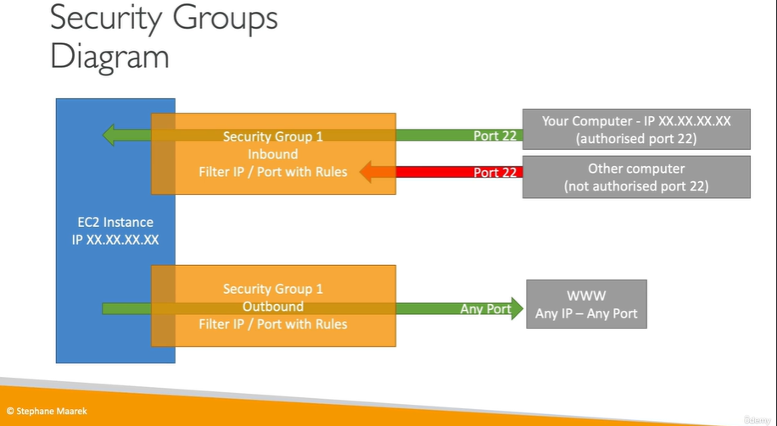

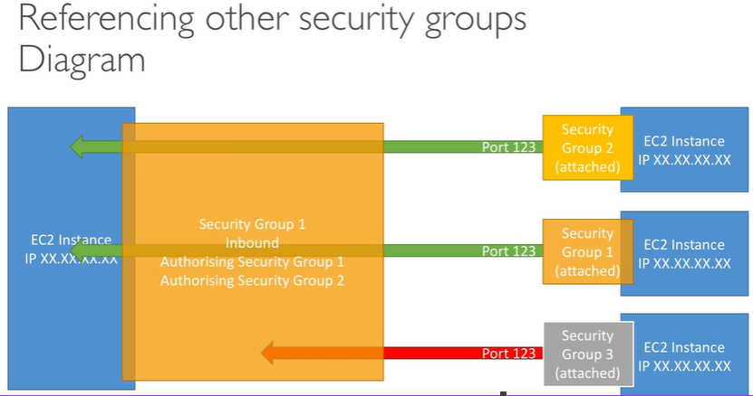

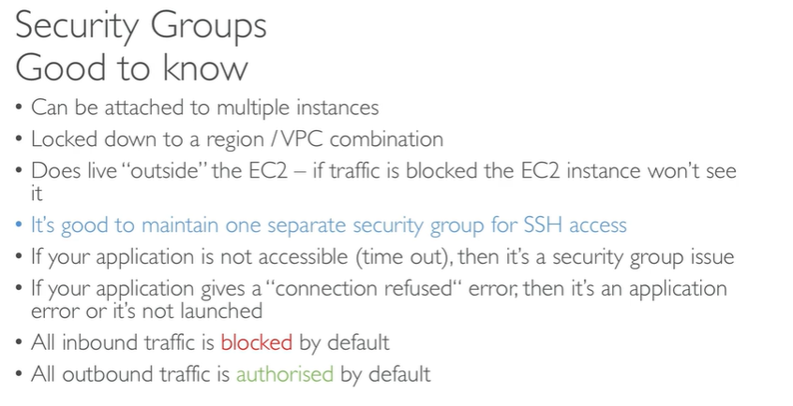

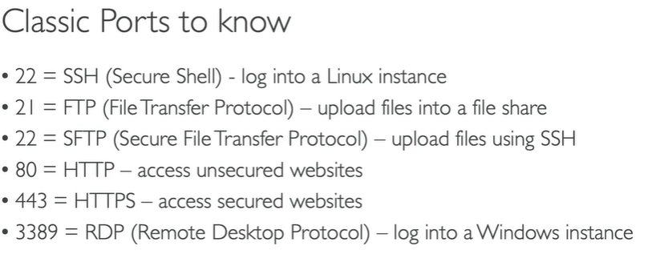

**Usage of Putty in AWS**:

* **EC2 Instances**: In AWS, users often deploy virtual servers called EC2 (Elastic Compute Cloud) instances. These instances run various operating systems, including Linux and Windows. To access and manage these instances, especially Linux-based ones, you often need an SSH client like PuTTY. PuTTY can be used to establish SSH connections to EC2 instances.

In summary, **PuTTY** is a versatile **tool** for establishing **secure connections (**btwclient computer and a server) to remote **servers** and networking equipment, and it's commonly used in AWS to manage **EC2** **instances** and perform various administrative tasks. While AWS provides its own **web-based** **management** console, PuTTY is a popular choice for more advanced users who prefer **command-line access** or need to work with instances that require SSH connections.



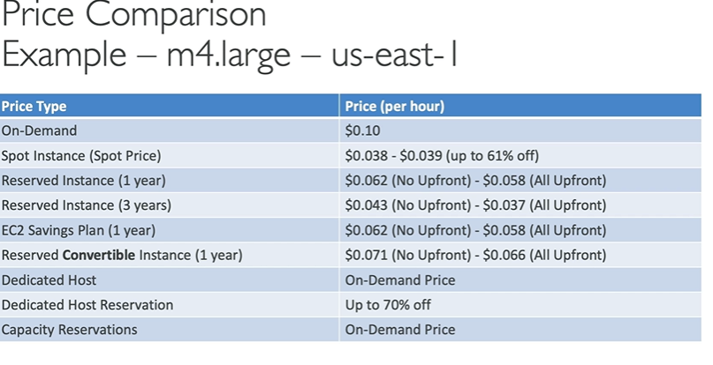

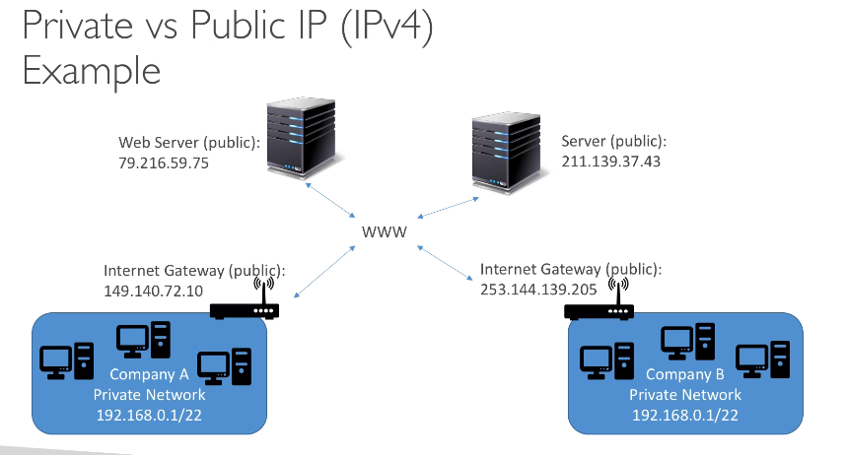

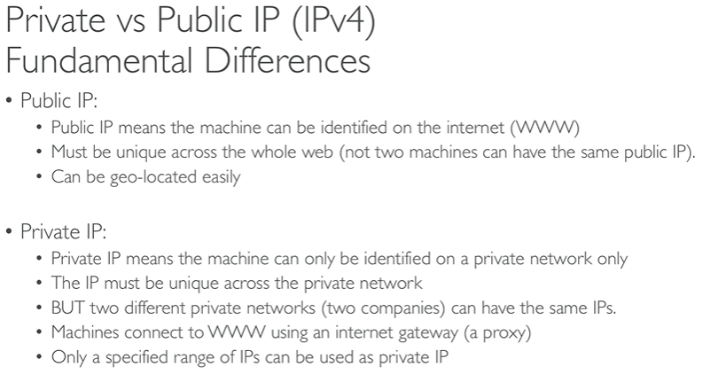

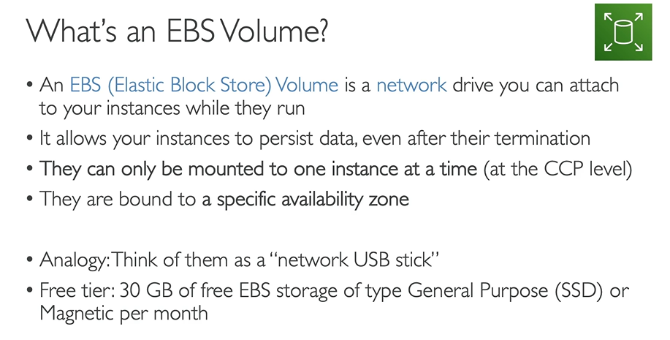

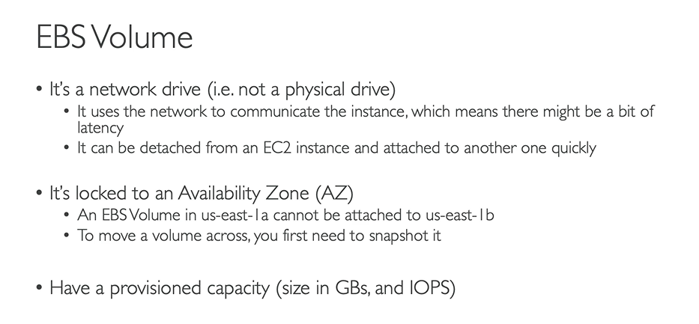

**Steps: - Instances – Storage – Create EBS volume**

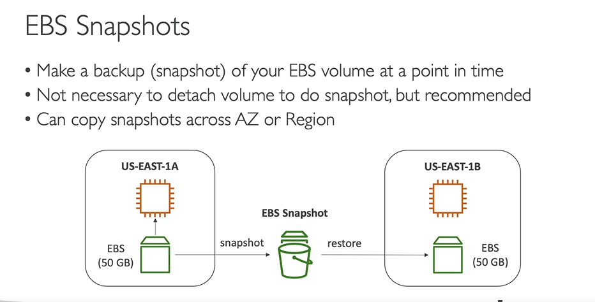

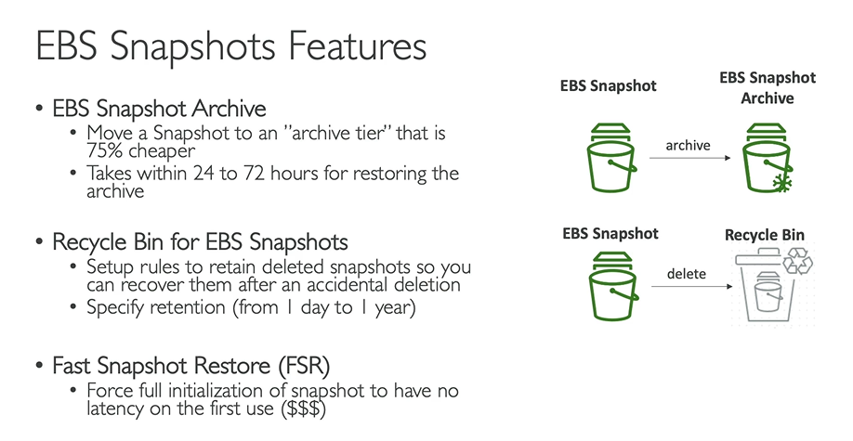

**EBS:**

* **snapshot –**
* **recycle**
* **accidental rule – create accidental rule**

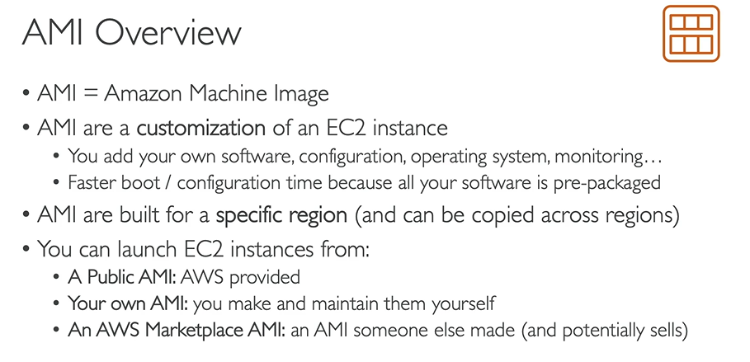

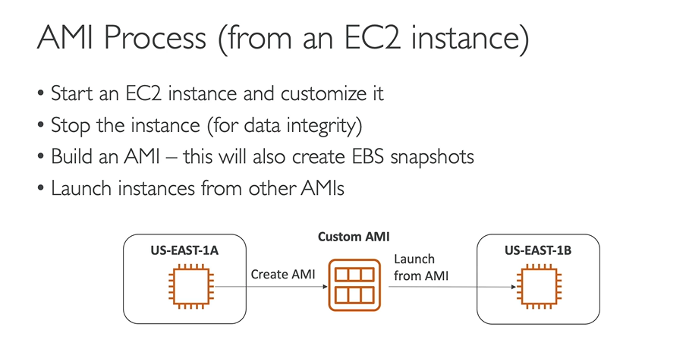

* **Create ec2 instances – add key pair – add security group - add user data in file**

#!/bin/bash

# Use this for your user data (script from top to bottom)

# install httpd (Linux 2 version)

yum update -y

yum install -y httpd

systemctl start httpd

systemctl enable httpd --(it will install **http** which is a **apache web server**)

* **Select ec2 instances – right click – image and templates – create AMI image**
* **Again Launch New Instances - add existing My AMI – select key pair - security group - Add user data -**

#! /bin/bash

# Use this for your user data (script from top to bottom)

# install httpd (Linux 2 version)

echo "<h1>Hello World from $(hostname -f)</h1>" > /var/www/html/index.html

* Browse the port with http you will get a echo message

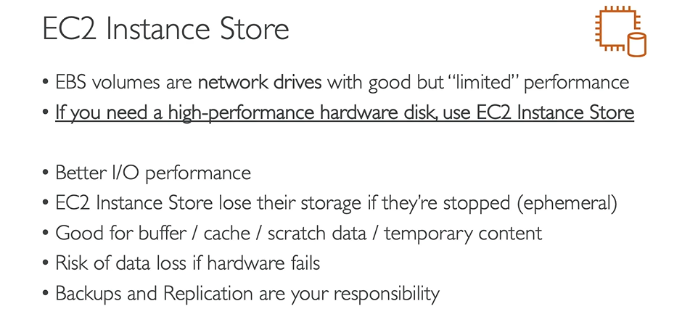

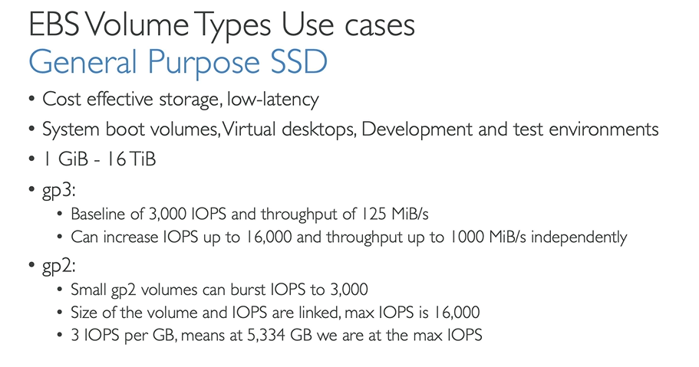

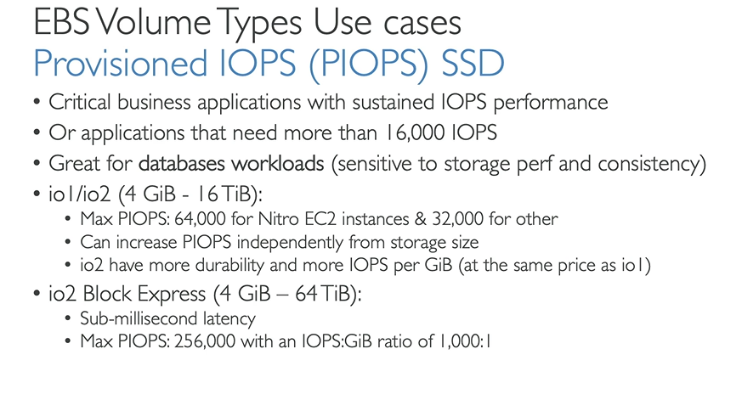

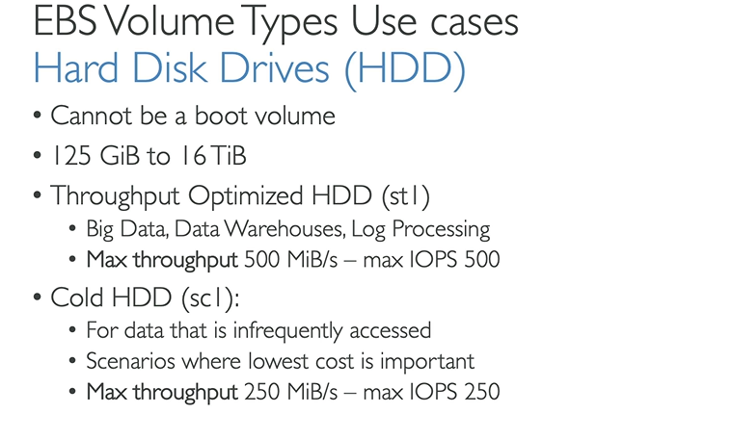

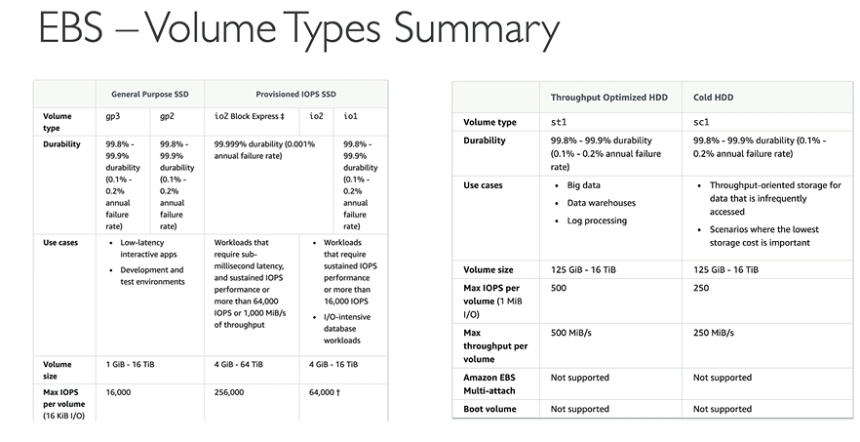

**EBS – Multi Attach –io1 and io2 family:**

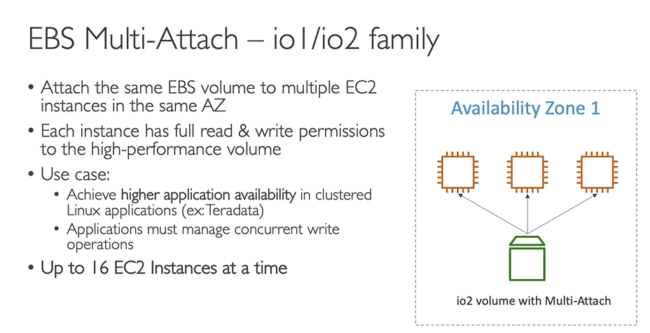

We can attach the same **EBS volume** upto time **16** instances at a time in same availability zone.

**How to encrypte EBS Volume:**

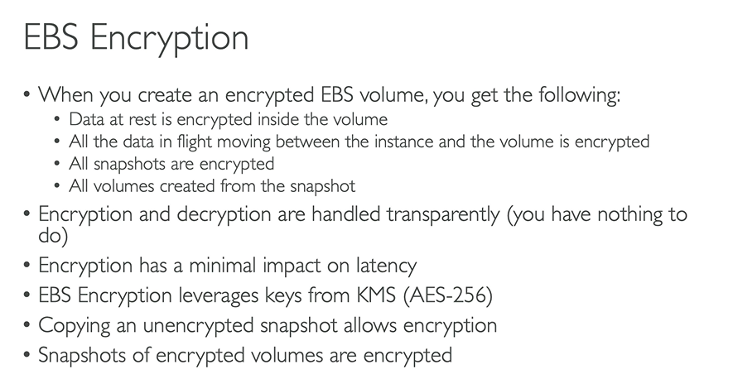

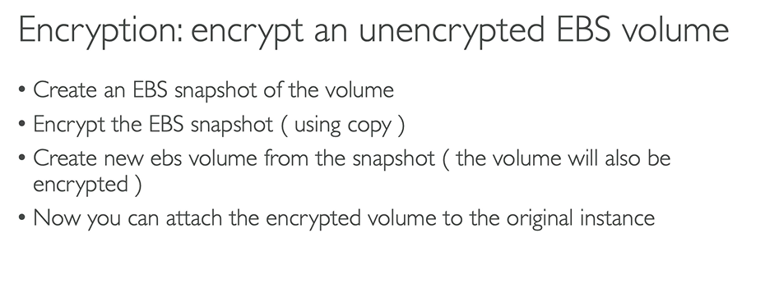

**Create EBS volume**

**Actions – create a snapshot from existing EBS volume - check in snapshot**

**Actions - Copy snapshot - add encrypt to this snapshot - copy snapshot**

**From encrypted snapshot – Action - create a volume from snapshot – create volume**

**Amazon Elastic File System:**

* **Managed NFS (network file system) that can be mounted on EC2 instances**

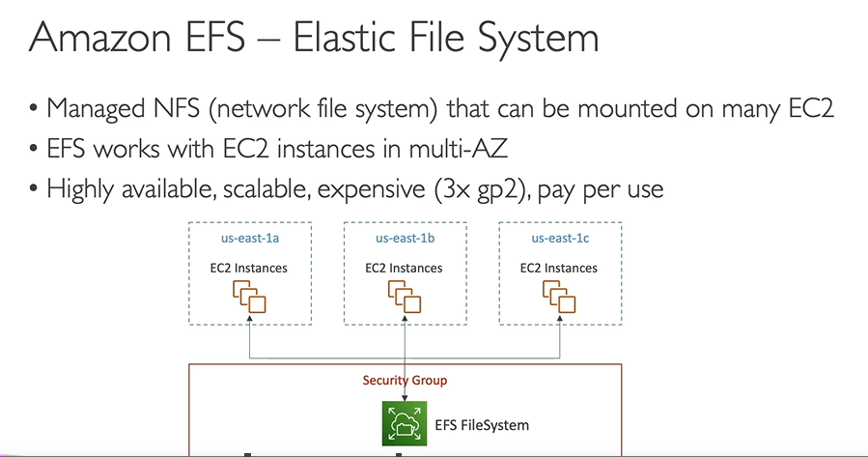

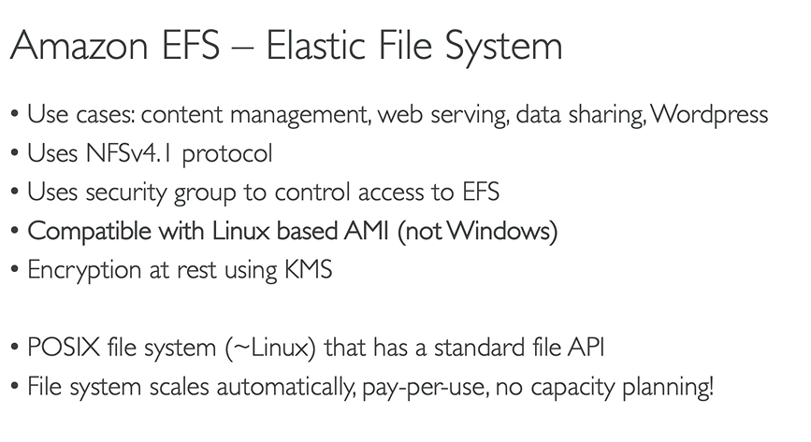

**Steps for EFS:**

* **Create EFS file system and mount our EFS to the ec2 instances**

EFS - customize

Availability zone and durability: regional (stores data across multiple A-Z zones) and one zone (single and reduce cost)

Performance setting: - throughput mode – enhanced - elastic (recommended)

Create specific security group and add to the EFS

File system policy – nothing to do

Create

* **Create 2 ec2 instances of different availability zones**

Launch EC2 instances - Linux - disable key pair – t2 micro – network settings – default –

Network Settings – add the subnet

File Systems – add EFS that we created - add shared file system and mount point

Number of instances – 1

* **Connect our 2 instances using EC2 Instance Connect**

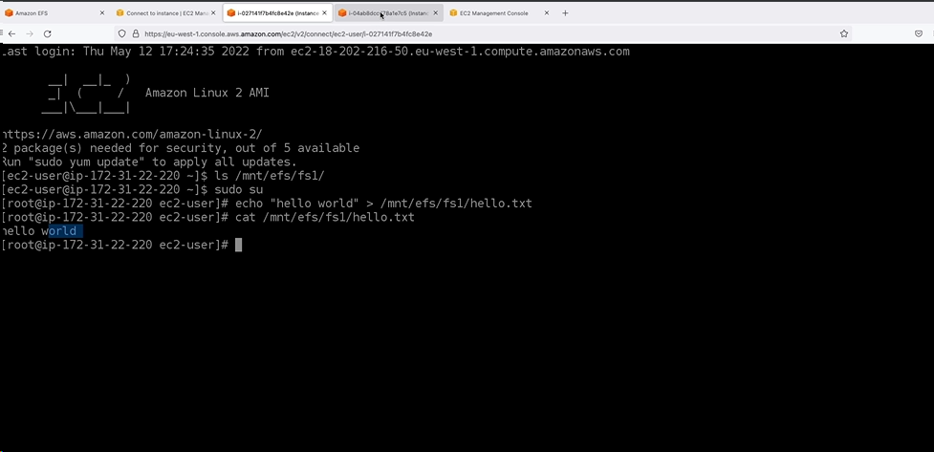

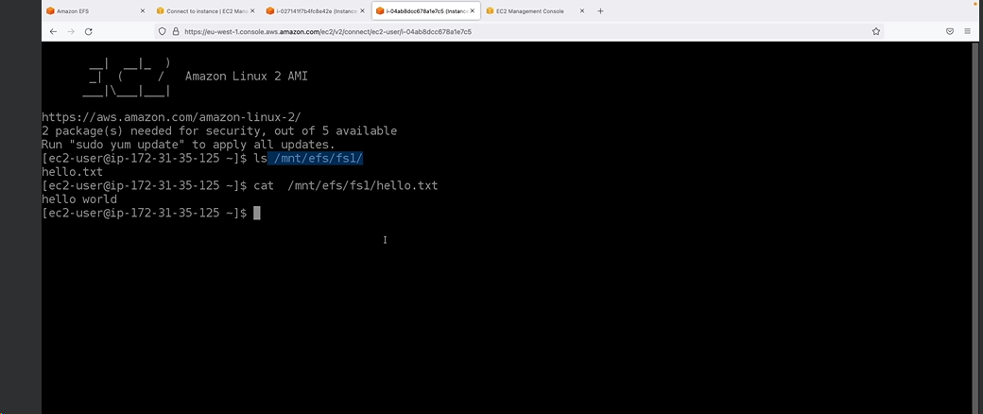

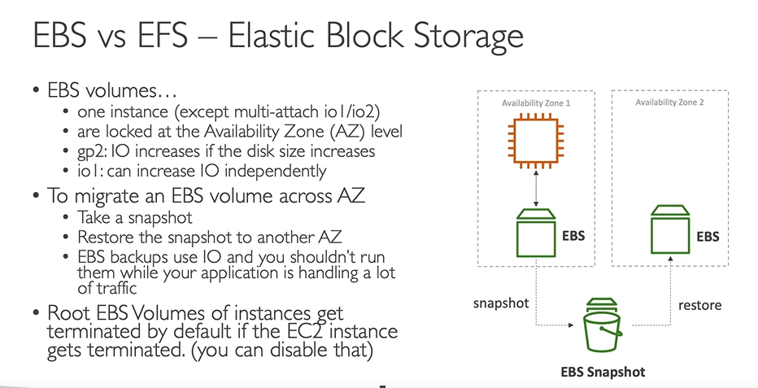

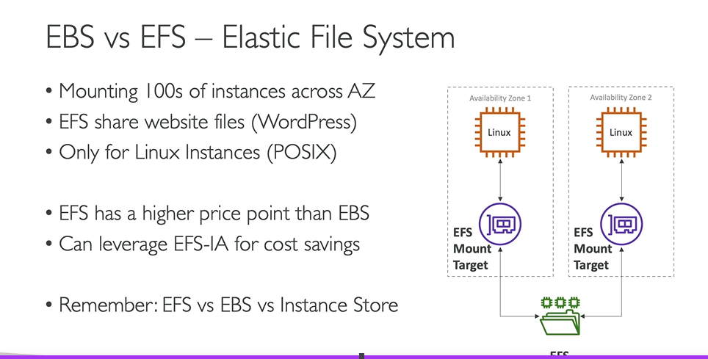

**Points to remember:**

* EBS Volumes are created for a specific AZ. It is possible to migrate them between different AZs using EBS Snapshots.
* By default, the Root volume type will be deleted as its "Delete on Termination" attribute checked by default. Any other EBS volume types will not be deleted as its "Delete on Termination" attributes disabled by default.
* AMIs are built for a specific AWS Region, they're unique for each AWS Region. You can't launch an EC2 instance using an AMI in another AWS Region, but you can copy the AMI to the target AWS Region and then use it to create your EC2 instances.
* When creating EC2 instances, you can only use the following EBS volume types as boot volumes: gp2, gp3, io1, io2, and Magnetic (Standard).
* Using EBS Multi-Attach, you can attach the same EBS volume to multiple EC2 instances in the same AZ. Each EC2 instance has full read/write permissions.
* EFS are a network file system (NFS) that allows you to mount the same file system on EC2 instances that are in different AZs.
* You would like to have a high-performance local cache for your application hosted on an EC2 instance. You don't mind losing the cache upon the termination of your EC2 instance. Which storage mechanism do you recommend as a Solutions Architect -- **Instance Store**?

You are running a high-performance database that requires an IOPS of 310,000 for its underlying storage. What do you recommend?

16,000 is the maximum IOPS you can achieve when you're using the EBS gp2 volume type.

64,000 is the maximum IOPS you can achieve when you're using EBS io1 or io2 volume types.

256,000 is the maximum IOPS you can achieve when you're using the EBS io2 Block Express volume type.

You can run a database on an EC2 instance that uses an Instance Store, but you'll have a problem that the data will be lost if the EC2 instance is stopped (it can be restarted without problems). One solution is that you can set up a replication mechanism on another EC2 instance with an Instance Store to have a standby copy. Another solution is to set up backup mechanisms for your data. It's all up to you how you want to set up your architecture to validate your requirements. In this use case, it's around IOPS, so we have to choose an EC2 Instance Store.

**Load Balancer:**

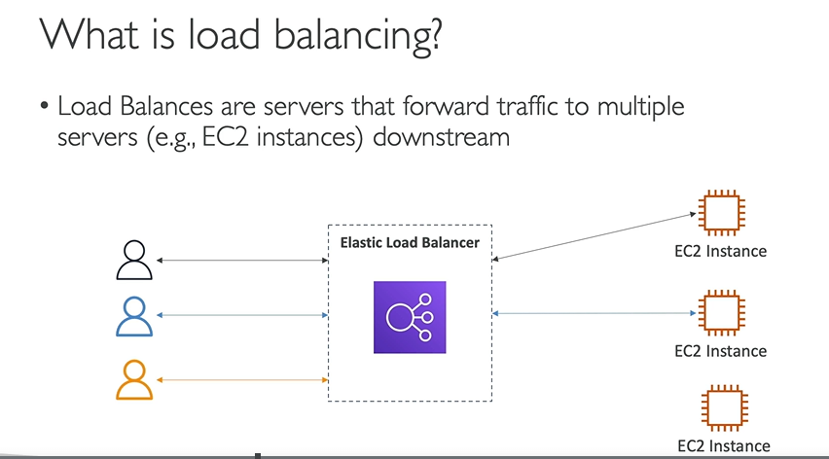

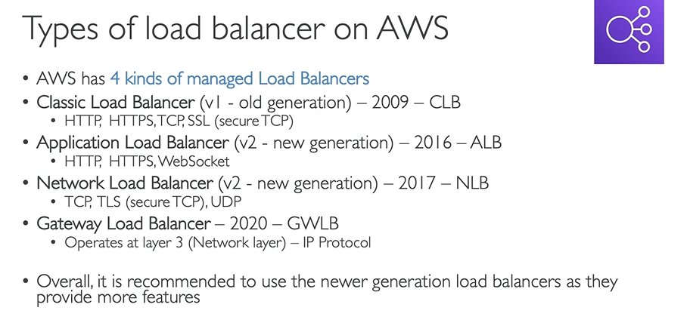

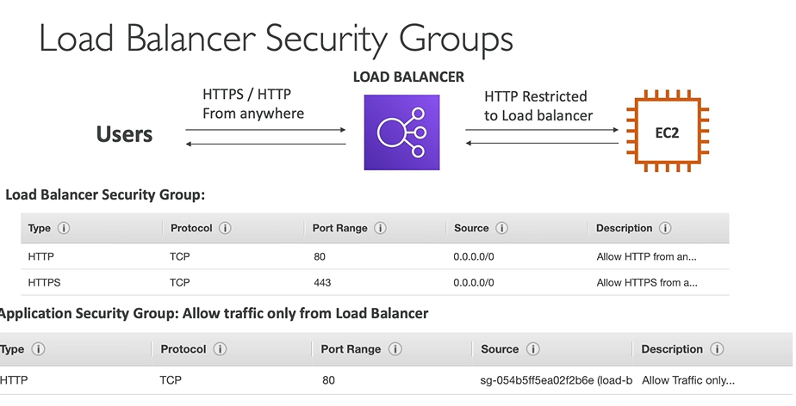

**Types:**

**Application Load Balancer:** with a 2 instances **(recommended) – in** same http URL we can balance 2 ec2 instances i.e. a load balancing

**Network Load Balancer:** with a 2 instances

**Gateway Load Balancer**

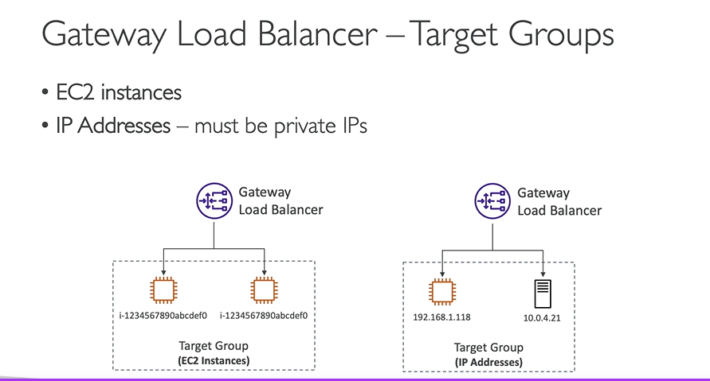

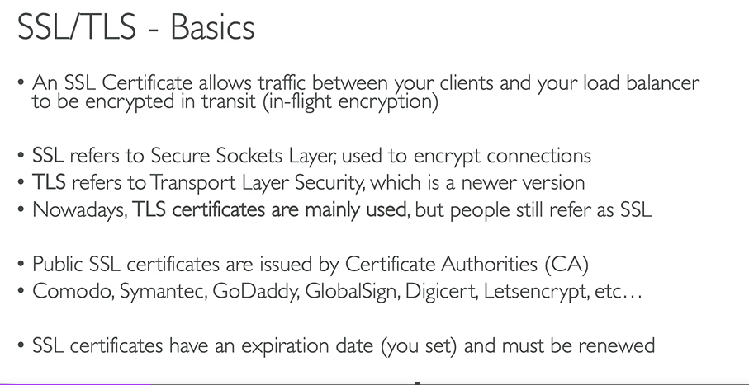

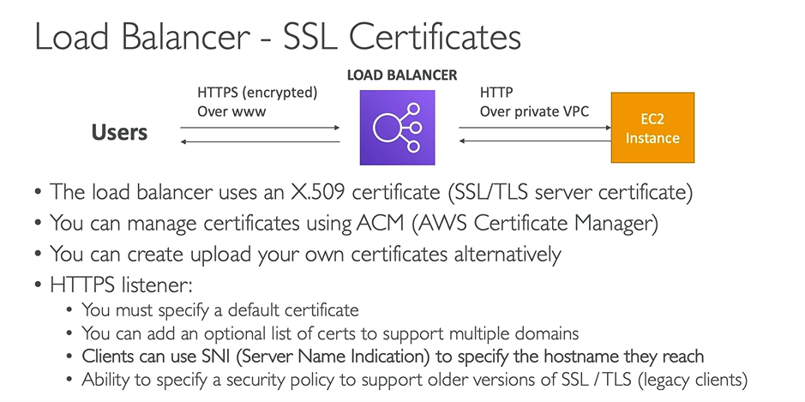

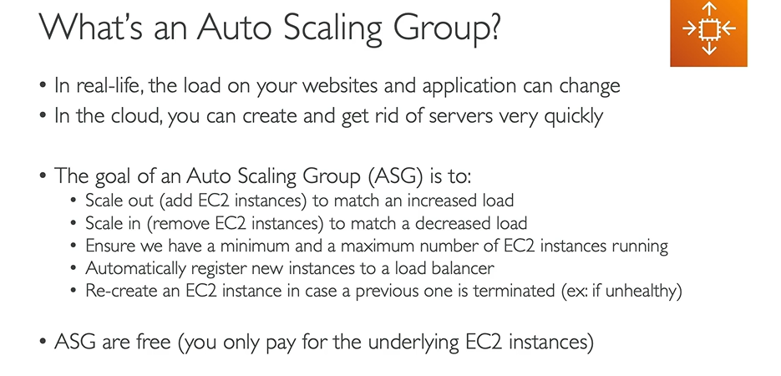

**Amazon RDS (Relational Database System):**

* It is a managed database service for DB use **SQL** as a query language.
* It allows you to create database in the cloud that are managed by AWS.

**Types:**

1. MSSQL
2. Maria DB
3. Postgres
4. Aurora
5. Oracle

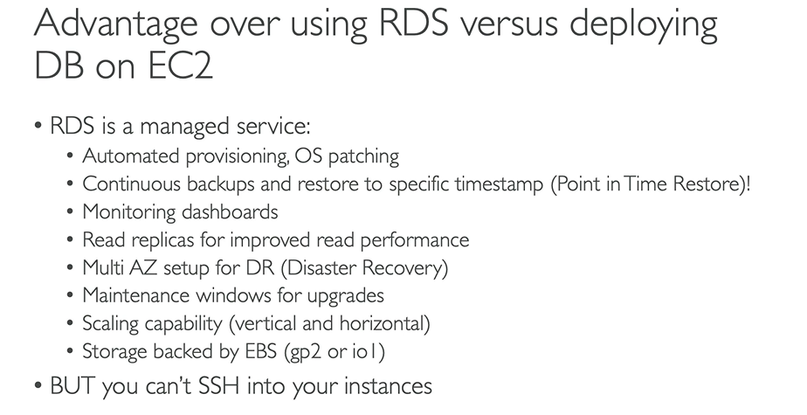

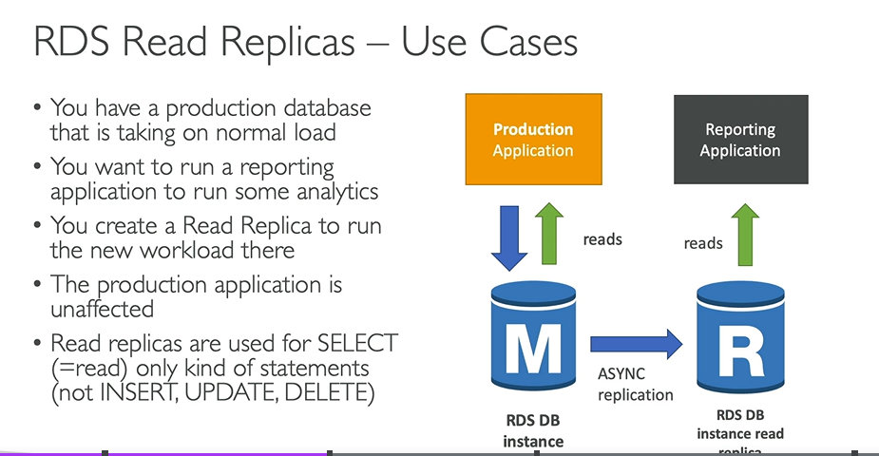

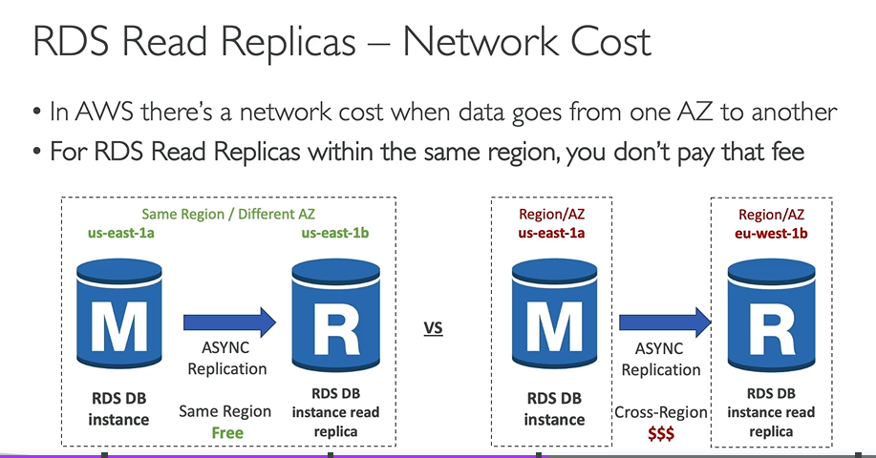

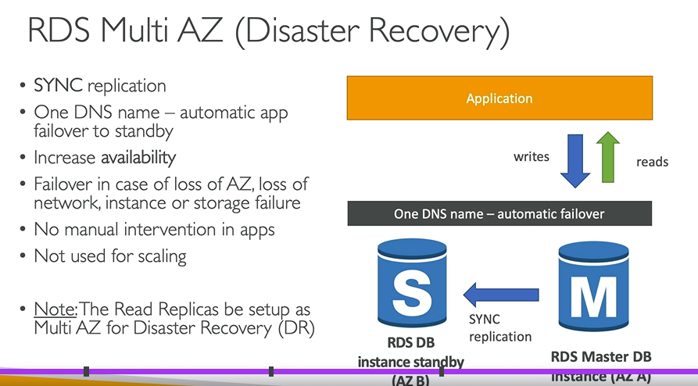

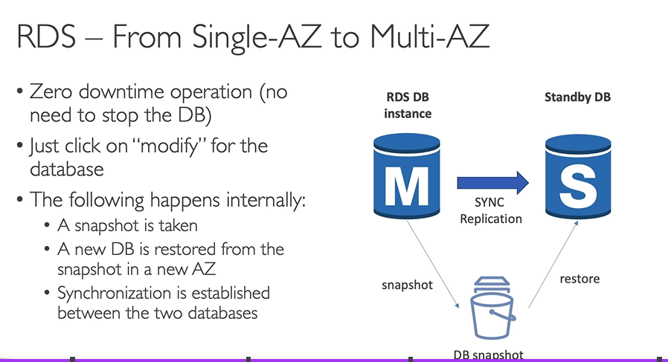

Create sample rds connection

Select existing RDS

* **Action** - Create reader replica
* **Action** – Take Snapshot
* Migrate snapshot to different region
* Restore to point in time

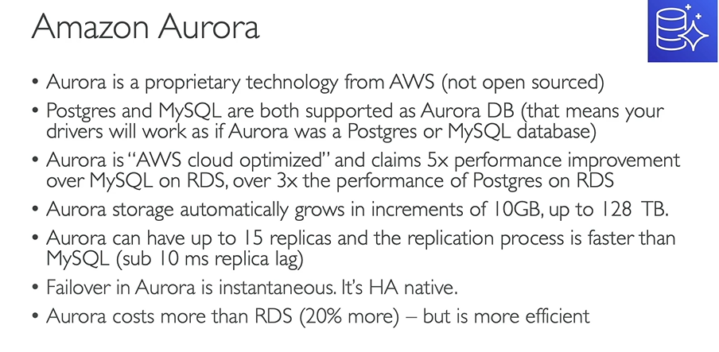

**AWS Glue:** is the full managed, server less ETL services.

**ETL –** extract transform load

**Extraction** – is the process of fetching/retrieving data from various data source and load into staging area for further process.

**Transformation** – is the process of performing operations like cleaning, aggregating, mapping, re-formatting and more on extracted data.

**Load** – is the process of inserting the transformed data into targeted database, data warehouse, data store from where the users and various processes can consume them

>all together is called **ETL job**.

>It has central MetaData Repository known as **AWS Glue Data Catalog**

>Apache Spark ETL engine

>flexible scheduler

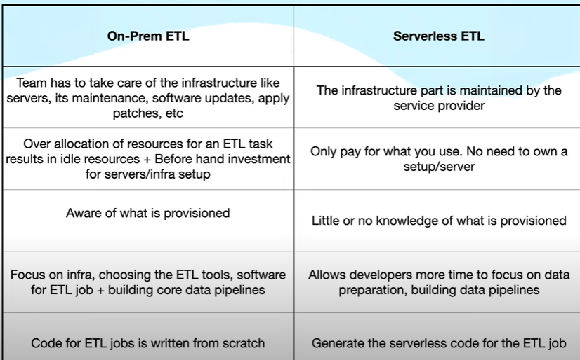

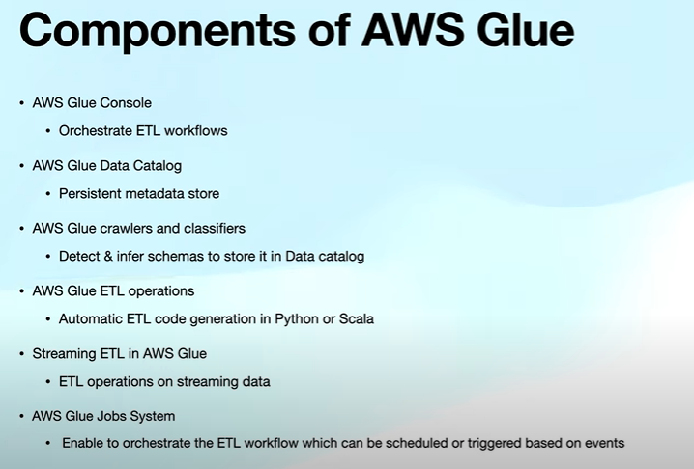

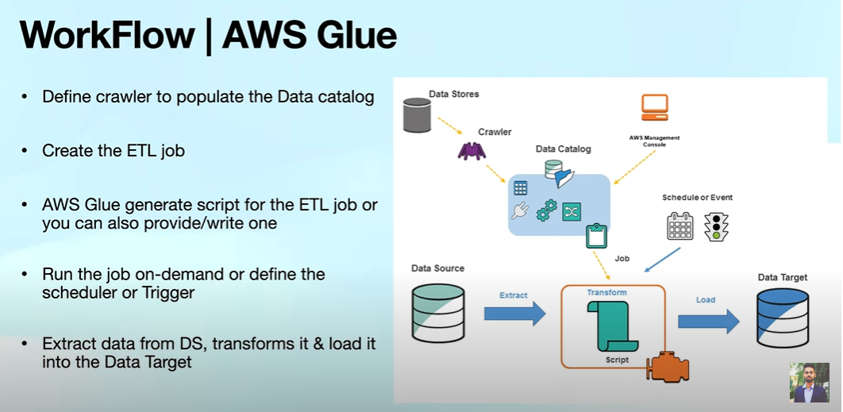

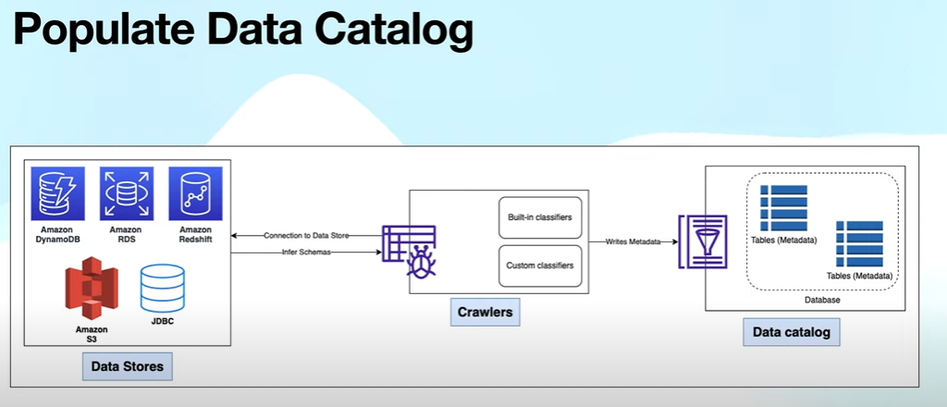

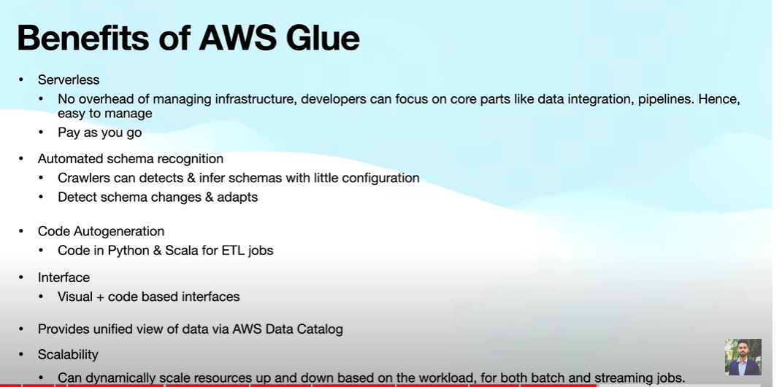

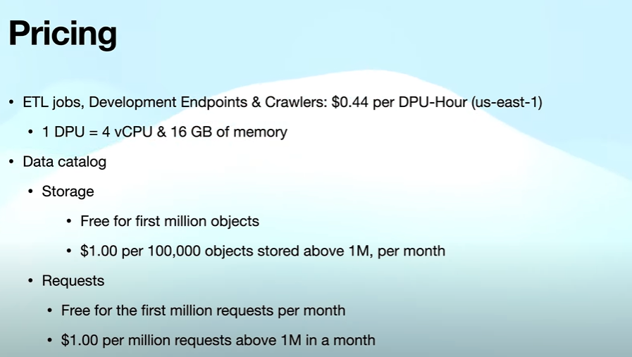

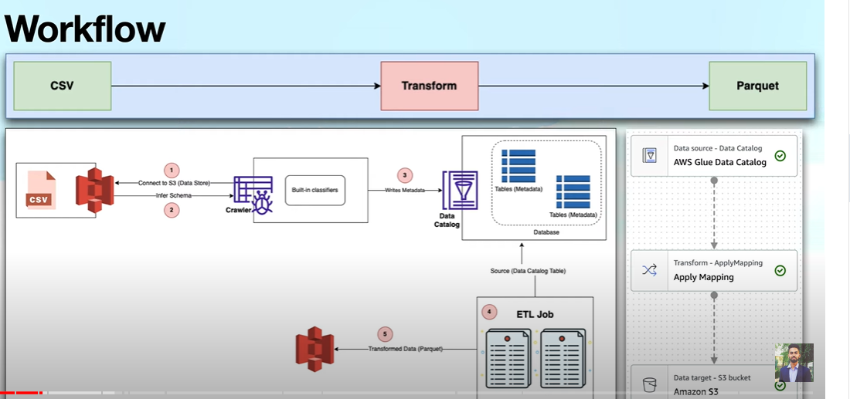

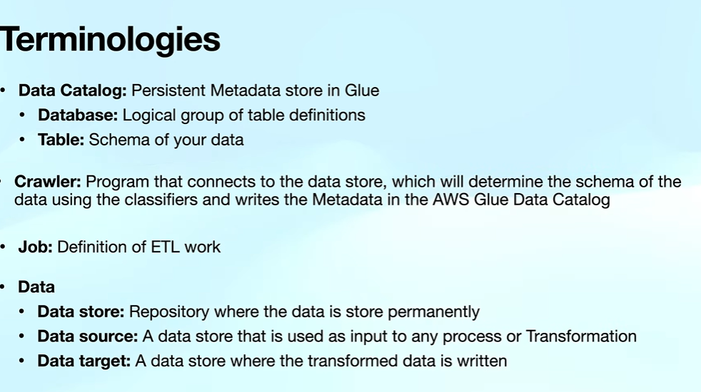

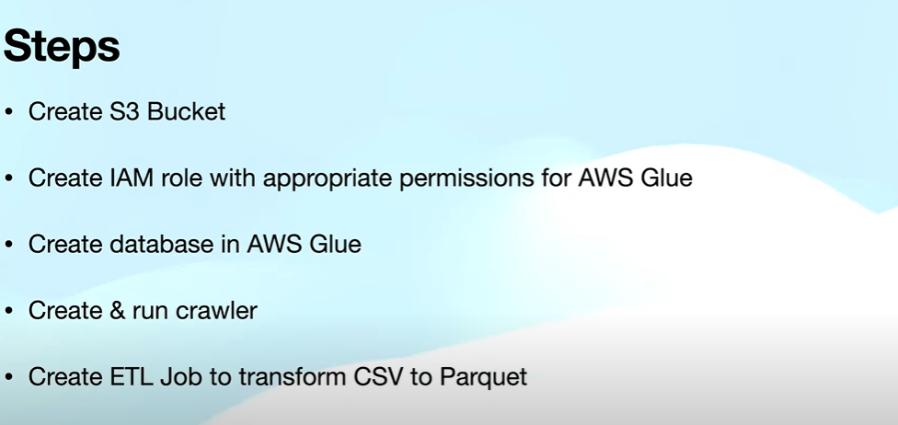

**S3** – Bucket-name always unique and does not contain capital letter.

**Services**:

**Data Lake** – can have all the data like structured data, unstructured data, and semi – structured where we can store raw data of real time

**Data warehouse**

**Database**

**Spark – scripts – python (pyspark)**

**>**

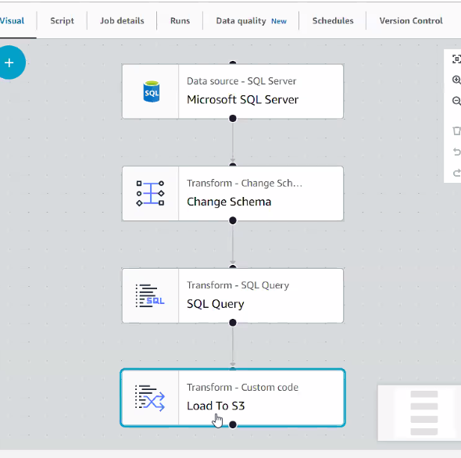

>simple notification services in AWS

**Day1:**

**Auto Scaling Group**

**Load Balancer:**

1) Classic Load Balancer

2) Application Load Balancer

**EBS: Elastic Block Store**

Auto Scaling Group: Scaling the Business Automatically

**Horizontal Scaling**: we are keeping on adding the new system.

**Vertical Scaling:** herewe are scaling the current system by increasing the size.

**Day 2:**

**RDS (Relational Database Service)**

What is RDS?

In summary, AWS RDS simplifies the process of setting up, managing, and scaling a relational database, such as MSSQL, in the cloud. You can write queries and interact with your MSSQL database just as you would with an on-premises database, while AWS takes care of many administrative tasks for you.

**Different Types of Database in RDS**

1. How to create Microsoft Sql server using Microsoft Management Studio

2) How to Create MYSQL server using MYSQL Workbench Tool

>**Endpoint** is the host name for connecting to server in mssql

3) How to create postgress server and connect to Dbeaver Tool

>>**Endpoint** is the host name for connecting to server in mssql

How to take Automated Backups

How to have Manual Backups:

1. **MSSQL Backup to S3 :**

exec [msdb].[dbo].[rds_backup_database]

@source_db_name ='test_database',

@s3_arn_to_backup_to = N'arn:aws:s3:::sqlserverdemo16102023/Backup1510.bak'

exec [msdb].[dbo].[rds_task_status]

By Default **Options Group** is default so there is no permission to backup the database to the s3 location

>we need to create a new **option group** and assign permission. Option group is having specific permission. We add those option groups to our instance. Now we can take a backup database to our s3 location

**>Engine -** ee(enterprise edition) and ex (express edition)

**Parameter Group:** is nothing but define the **configurations** according to your requirements

**Read Replica**, how to make replica instance from your instance -

>**Reader replica** is nothing but giving reader replica of our own database to external team ex: Digital Marketing or Business Intelligence.

>Action -- read replica.

> Action – **Primary** - we can insert data -- if we made primary.

> It is not available for many databases but here for postgress its working

Amazon.com ----- Application ----- Database

Database Reader Replica

Business Intelligence or Digital Marketing

MSSQL RDS – ACTIONS – CREATE READER APLICA --- source of the database - db instance identifier (name)

How to promote read replica to primary instance - **Action** - **Primary**

**Amazon DynamoDB:** to handle huge data**.**

Where we can create a table by one click and can perform any operations here

**Default Settings:**

**WCU (write capacity unit) –** 1 wcu - 1/kb/per second can write per sec - it can write the record 1 kb per sec

**Ex: working with amazon – we have sales data**

**SaleId ProductName price discount address etc….**

1. **Computer 100 5**
2. **desktop 200 8**

**How we can calculate:**

**Consider For 1 record we are taking 500 bytes randomly**

Ex: we are writing 8000 records 8000/60 = 1333.333 per min == 1333/60 = 22 records writing per/sec = multiply by 500 we get 22 * 500 = 11000 convert it into kb = 11000/1024 = 10b kb

But in aws if you are taking 1 wcu then it will allow 1 kb per sec to write

**RCU (read capacity unit) –** 1 rcu - 4/k/per second for reading data

**Customize Settings:**

**Table class:**

**1) Dynamodb standard –** huge data

a) on-demand – aws will handle.

b) Provisioned - auto-scaling - on/off - 5 default

2) standard-IA - where we use your data once in a month or 2 months then use this

**Note :DynamoDB client** is an external tool to connecting to DynamoDB for creating and inserting records.

Global Tables in DynamoDB

Export/Import features of DynamoDB

Dynamo Streams

What is lambda function?

Integrate Lambda Function with DynamoDB (DynamoDB Streams)

Use cases of lambda

Basic lambda creation

Caching Databases

Redis Cache

System Manager (Take a RDB without opening 3389 port)

**RDS: Relational Database System (sql server, postgress, mysql, etc ...)**

**Characteristics:**

1. Database engine support
2. Independent scaling
3. Automated backups
4. IAM integration ( get access for iam users can be perform in rds)

Cloud Computing

Load Balancing

Auto Scaling

Database

VPC

**Today: (10/30/2023)**

EBS, EFS

Lambda

Integration to EFS with Lambda

S3

S3 storage classes,

S3 versioning

S3 replication tools

S3 life cycle rules

S3 integration to lambda

S3 static website hosting

S3 endpoints access points

1. EBS (elastic block store) : Increasing the volumes of the ec2 instances

**IOPS** stand for "Input/Output Operations per Second." It is a metric used to measure the performance of storage devices, such as hard drives, solid-state drives (SSDs), and storage systems. IOPS indicates how many read and write operations a storage device or system can handle in a single second.

Ec2 - launch ec2 - windows – create key pair – vpc – subnet – launch ec2 – launch ec2 – actions – security - get windows password – upload pem file – get password – download – action – RDP client – download remote file – connect by specifying the password

Go to – EBS – volumes – expand the storage - create the volume

Attach the volume - actions – attach volume – attach the instance

Go to remote – search computer management – storage – disk management – disk 1 – right click – make it online – again right click – make it online – again right click – new simple volume – next – next - add new hard disk – next – finish

/**dev/sda1 -** is a root volume - it is deleted when instances is deleted

**Xvdf** is a data volume – data volume will not be deleted when you deleted your instances.

**SnapShot** – means backup - in order to take the backup of the volume -- go to volume – actions – create the snapshot of the volume

We can create a volume from snapshot anytime - snapshots – actions – create volume from snapshots

**LifeCylce Manager:** define a rule and create a schedule for everyday snapshot data

1. **Elastic File System**: is a network file system – is when you want configuring network on your system – it’s a network file share – share the data to everyone.

EFS only supports for **Linux**

>we need to mount for linux machine

1) Creating EFS

2) Create 2-3 ec2 instances

3) Add NFS to security group (2049)

4) Replace security group of ec2 to efs

5) Install EFS-Util

6) Mount efs to ec2 instances

7) Testing

1. Go - EFS - create a file system

2. Create a 3 ec2 instances – of aws linux – create key pair – launch

3. Go to ec2 instance – security –security groups - edit inbound rules - add a new rule NFS (network file system) - port 0.0.0.0/0 - save - to allow the traffic

4. Go to EFS - Network – security group default change to – my security group – click on manage – add ec2 instance security group to it – done

5. Go to our instances – copy public ip - go putty – paste the ip in the host – click on appearance - change

Go to Auth – credentials - browse the ppk file – click open – accept – login ec2-user –

**Commands for EC2 command Prompt:**

**Step 1 for all 3 ec2 instances:**

**Sudo su** - convert ec2 user to root user

**Yum install –y amazon-efs-utils -**it will install amazon efs-util

**mkdir efs** -create a directory

Go to EFS - click on attach – copy efs mount helper - paste in ec2 command prompt of 3 instances

**Sudo paste efs mount helper here**

**Step 2 will be same for all 3 ec2 instances i.e. mount:**

**cd efs/**

**vim newfile** - to create a new file

Press “ i ” - to insert

type text :

Write something “welcome to new file”

Press **esc: wq!** - To save and only :**q!** - For Quitting

**ls**

Go to second ec2 command prompt:

**Cd efs/**

**ls**

**Cat newfile** -display the content

This how sharing the data between multiple Instances.

1. **Lambda Function:** in order to control the coast ec2 instances we use lambda where ec2 is not used in such a scenarios**.**

* **For use cases we use this**
* **Create a sample lambda function –edit configuration – to increase the size**

1. **Integrate Lambda Function with efs:**

**1) Create a security group (default)**

**2) Create EFS file system i.e. search EFS**

**3) Change security group for efs**

**4) Create accesss point in EFS:**

* **Posix userid : 1000**
* **Directory path /access**
* **Group id : 1000**
* **Owner user id :1000**
* **Owner group id :1000**
* **Access point permissions :777**

**5) create IAM role (efs – lambdarole)**

**AwslambdaExecute**

**AWSLambdaVPCAcessExecutiveRole**

**AmazonElasticFileSystemClientFullAccess**

**6) Create lambda function and update VPC while creating the lambda function**

* **Advanced settings : enable VPC and choose VPC , subnets and security groups(choose one i.e. EFS one i.e. in network – security groups)**

**7) Configure EFS to Lambda Function - go to configuration – file system – add a created file system**

**Local mount path -- /mnt/access**

**Code:**

Print (“before: “, os.listdir (“/mnt/access”))

With open (“/mnt/access/somefile.txt”,”w”) as f:

f.write (“hello from lambda”)

Print (“after: “, os.listdir (“/mnt/access”))

S3 (Simple Storage Service) :

**AWS by Durga-Prasad:**

**Installation of WSL:**

The Windows Subsystem for Linux (WSL) is a feature of the Windows operating system that enables you to run a ***Linux file system***, along with ***Linux command-line tools*** and ***GUI apps***, directly on Windows, alongside your traditional Windows desktop and apps.

**Ubuntu on windows:**

**Username:** Dhruvan_123

**Password:** Dai@2020!

**wsl --install -d Ubuntu-20.04** -Toinstall ubuntu on windows sub-system

**wsl -l –v** to get the list virtual machines

**Exit ()**: to exit out of virtual machine

**Wsl –d (name of the distribution)** - if you have multiple virtual machine and connect to particular vm use this command

**Ex**: **wsl –d Ubuntu-20.04**

**Ls –ltr** -to get list of files and folders

**pwd** - present working directory

**sudo apt-get update** - it will update all the lists and try to install software from these lists

**sudo apt-get install python3-venv** - set up python virtual environment

**sudo apt-get install python3-pip** - set up pip on ubuntu

**python3 -m venv demo-venv** – create virtual environment with name demp-venv

**rm -rf demo-venv/** - to remove

**pip install configparser -** working with configuration files.

**Awscli -** The command **pip install awscli** is used to install the AWS Command Line Interface (CLI) via the Python package manager, **pip**. The AWS CLI is a unified tool that provides a command-line interface for interacting with various AWS services.

* **sudo snap install aws-cli –classic**
* **sudo apt-get update**
* **sudo apt-get install awscli**

**To configure your AWS CLI with specific credentials for a particular user for interacting with various AWS services**

**aws configure** -- specify the IAM user (secret key and access key needed)

**aws s3 ls –** to get list of buckets

**aws configure --profile awsdemo** - to set the specific user to aws CLI

**aws s3 ls --profile awsdemo -** to get list of buckets of a specific user

**cat ~/.aws/credentials** - to verify configure is correct or not

**rm ~/.aws/credentials** - to remove the user from aws CLI

pip install --upgrade awscli - to update the aws cli

**Steps by Practical’s:**

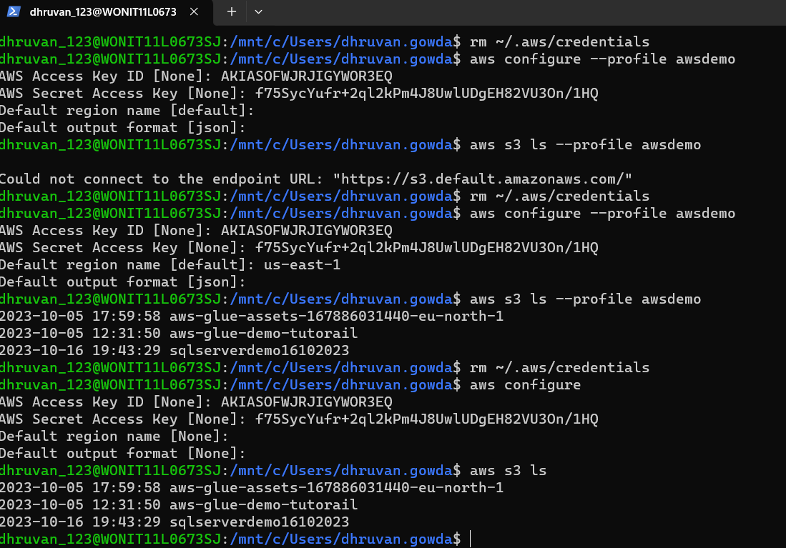

**This is our environment details:**

**PS C:\Users\dhruvan.gowda> wsl -d Ubuntu-20.04**

**dhruvan_123@WONIT11L0673SJ:/mnt/c/Users/dhruvan.gowda$ cd /mnt/c/Users/dhruvan.gowda/Projects/Internal/bootcamp/data-engineering-on-aws/**

**dhruvan_123@WONIT11L0673SJ:/mnt/c/Users/dhruvan.gowda/Projects/Internal/bootcamp/data-engineering-on-aws$ source de-venv/bin/activate**

**We get like this:**

**(de-venv) dhruvan_123@WONIT11L0673SJ:/mnt/c/Users/dhruvan.gowda/Projects/Internal/bootcamp/data-engineering-on-aws$**

**To create a directory**

**mkdir –p**  –dir name-

**cd –**dir name-

**To create a venv environment**

**python3 –m venv** de-venv

**find** de-venv

**To activate the venv env**

**source** de-venv/bin/activate

**Set up Boto3 as part of python virtual environment (install SDK to interact with AWS CLI by the name called BOTO3)**

Pip install boto3

>>> import boto3

>>> sc_client = boto3.client ('s3')

>>> sc_client.list_buckets ()

**Set up Jupyterlab to interact with AWS CLI**

**pip install boto3**

**Pip install jupyterlab –** install all the packages of the jupyter notebook

**Jupyter lab -** to get the URL of the jupyter notebook

**Cloud9 [run on ubuntu os]**: Cloud9 is an integrated development environment (IDE) that allows developers to write, run, and debug code in the cloud. It provides a web-based interface that allows users to access their development environment from any device with an internet connection.

**Git**

**Docker ps**

**Docker ps –a -** to see if any containers created

**Sudo systemctl status docker -** to check docker is running or not

**Python**

**Java -version**

**Docker run hello-world -** it will create a sample docker images by the name hello-world and check the status by a command **docker ps –a**

**Docker images**

**Docker rm docker-id -** it will remove the docker images by ID

**Docker rmi image-name -** it will remove the docker images by name

**Accessing web-application through cloud9:**

**Sudo systemctl status httpd –** tocheck http server is installed or not

**Sudo systemctl start httpd –** it will start the http server

**Sudo yum install telnet –y** – Telnet is typically used to validate whether we are able to listen to the web service that is

running on a particular server on a particular port.

**Sudo systemctl status apache2** -

**Allocate and Assign Static IP**

Elastic IP addresses (EIPs) in AWS provide a **static** and **permanent public IP address** and same **DNS** for your **EC2** instances. Even if you stop and then later restart the EC2 instance, the Elastic IP address remains the same

**Steps**:

* Network and security
* Elastic IP
* Change the name
* Actions – associate elastic ip address - add the current EC2 instances
* In cloud9 restart httpd server by **sudo systemctl start httpd**
* Access the public ipv4 dns on ec2 in browser by[**http://ipv4**](http://ipv4) **dns**

**Changing permissions in IAM Policies**: in groups that will effect to the user

**EBS (elastic block storage):**

* Used to increase the size of EBS volume
* By default cloud9 instances are created with 10 GB storage
* We might run into No spaces left on devices issues
* We can increase the size of EBS volume to mitigate the issues
* Go to **actions** and click on **modify volume**
* You can increase the volume size up to desired values
* You need to restart the instances to be able to use the new size

**Setup Jupyter Lab on Cloud9 Instances:**

* **Mkdir**
* **Cd**
* **Python –m venv my-venv –** to create a new virtual environment
* **Find my-venv/** - to validate what are files and folders are there in my virtual environment
* **Ls –ltr my-venv/bin** -we can see python and pip commands
* **Source my-venv/bin/activate –** to activate our virtual environment
* **Pip install jupyterlab**
* **Jupyter lab --ip 0.0.0.0 –**to start the jupyter lab web server
* **telnet localhost 8888 -** to get the status of the server
* Extra:-
* **nohub jupyter lab –ip 0.0.0.0 &** - to run the lab in background
* **tail nohub**.out - to get the token in background

**To talk to jupyter lab Go to EC2 instance:**

* public DNS –copy – access by <http://copy> dns:port(8888)
* we need to open the port 8888 on security group of ec2 of cloud9
* security group – inbound round rules – edit – add rule – custom tcp –port – my ip – save
* now open the link now
* specify the token or password in cloud9 **Jupyter lab --ip 0.0.0.0**

**[Instructions] Create s3 Bucket**

Let us create an s3 Bucket using AWS Web Console. It will be used to store GitHub Activity Data.

* Go to AWS Web Console and go to s3.
* Create a new bucket by name **awsdemo-bucket-2023.**
* We can also create folders for **landing** and **raw** zones for our data.
* The **landing zone** will be used to ingest data from **external** **sources**.
* We will store data in the landing zone using **JSON**. Typically data in the landing zone will be deleted. It will act as a scratch pad and we can delete data that is older than 30 days or as per the SLAs.
* The **raw zone** will be used to store data from sources following our **data lake standards**. In our case we will use **parquet** as target file format and partition all the data on a daily basis.
* We will have the data in the **raw** zone up to **7** to **10** years in most of the cases as part of **data lakes.**

**[Instructions] Create IAM Group and User**

Let us create an IAM Group as well as User to have access to GitHub Activity data and associated jobs. Typically, this step is taken care of by the AWS Admin or DevOps team.

* Go to IAM Console and add a group by the name [**AWSGithubGroup**](https://us-east-1.console.aws.amazon.com/iam/home?region=us-east-1#/groups/details/AWSGithubGroup).
* Go to IAM Console and add the user by name [**AWSGithubUser**](https://us-east-1.console.aws.amazon.com/iam/home?region=us-east-1#/users/details/AWSGithubUser). Let us add the user to the group [**AWSGithubGroup**](https://us-east-1.console.aws.amazon.com/iam/home?region=us-east-1#/groups/details/AWSGithubGroup). We will give both AWS web console as well as programmatic access to the user.
* We will only use this user using programmatic access. Make sure to download credentials so that we can configure AWS CLI on our desktop or laptop later.
* All the permissions that are attached to the group via policies will be inherited by all the users in the group.
* Typically we will have multiple users associated with a project and hence we create a group and add all the other users associated with the project.
* We might even have different groups with different permissions in a large scale project. For example, developers, testers, business analysts, devops engineers or administrators etc.

**[Instructions] Overview of Roles**

Let us also get an overview of AWS IAM Roles. They are typically associated with services such as ec2, emr, glue etc to get permissions on other services.

* For a Data Engineering or Data Lake project on AWS, we might have to use multiple services such as Glue, Kinesis, EMR, Athena etc.
* The services **typically interact** with other services and the standard way to grant required permissions is by creating **IAM Role**.
* We can create roles using IAM Web Console. Similar to Users or Groups, roles also inherit permissions via policies.

**[Instructions and Code] Create and Attach Custom Policy**

Let us create a custom policy and provide required permissions on the s3 bucket created earlier.

ALL the users belonging to the group inherited the permissions that are associated with the **policies**.

* We grant permissions to roles or to users via groups by attaching policies with them.
* We can either use AWS Predefined Policies or create custom ones.
* In this case we will create a custom policy by name **AWSGithubS3FullPolicy** by adding a custom definition.
* Search in Google s3 bucket with **read** and write **policy**

1. {
2. "Version": "2012-10-17",
3. "Statement": [
4. {
5. "Sid": "ListObjectsInBucket",
6. "Effect": "Allow",
7. "Action": [
8. "s3:ListBucket"
9. ],
10. "Resource": [
11. "arn:aws:s3::: **awsdemo-bucket-2023**"
12. ]
13. },
14. {
15. "Sid": "AllObjectActions",
16. "Effect": "Allow",
17. "Action": "s3:*Object",
18. "Resource": [
19. "arn:aws:s3::: **awsdemo-bucket-2023**/*"
20. ]
21. }
22. ]
23. }

Let us attach policy to users via group.

* Go to the **AWSGithubGroup** and attach the policy **AWSGithubS3FullPolicy**.
* All the users which are already added as well as users that will be added in future will automatically inherit the permissions to manage objects in the bucket.
* Now we need ensure users in the group are able to access s3 using **aws cli**.

Access S3 using AWS CLI:

Steps:

* rm ~/.aws/credentials
* aws configure --profile AWSGithubUser -for a particular user
* ls -ltr ~/.aws/credentials -here we get location of credentials
* cat /home/dhruvan_123/.aws/credentials –display the credentials
* aws s3 ls s3://awsdemo-bucket-2023 --profile AWSGithubUser -list all the buckets

**S3 (simple storage service):**

* **S3** stands for simple storage services.
* It is a **low** coast cloud based **permanent** storage accessible from anywhere based upon the permissions.
* Bucket name must be **unique** throughout the universe or world.
* S3 uses **object** storage (not file storage)
* [dhruvan_123@WONIT11L0673SJ:/mnt/c/Users/dhruvan.gowda/Projects/Internal/bootcamp/data-engineering-on-aws$](mailto:dhruvan_123@WONIT11L0673SJ:/mnt/c/Users/dhruvan.gowda/Projects/Internal/bootcamp/data-engineering-on-aws$) cd Research/data
* [dhruvan_123@WONIT11L0673SJ:/mnt/c/Users/dhruvan.gowda/Projects/Internal/bootcamp/data-engineering-on-aws/Research/data$](mailto:dhruvan_123@WONIT11L0673SJ:/mnt/c/Users/dhruvan.gowda/Projects/Internal/bootcamp/data-engineering-on-aws/Research/data$) git clone <https://github.com/dgadiraju/retail_db.git>
* mkdir –p dir_name = to create a dir without sudo user with multiple sub folders.
* dhruvan_123@WONIT11L0673SJ:/mnt$ sudo mkdir -p Research/data = create a folder with sudo user
* rmdir directory_name = to remove empty folder
* rm -r directory_name = to remove folder and contents inside the folder
* rm -rf directory_name = forcefully removing
* rm -ri directory_name = confirm before removing
* dhruvan_123@WONIT11L0673SJ:/mnt/Research/data$ sudo git clone <https://github.com/dgadiraju/retail_db.git> = to clone the repository
* ls –ltr = to get list of files with all permissions

**[Instructions] Version Control in AWS S3**

Let us understand the details related to the versioning of the S3 Bucket. We will also configure the basic life cycle.

* Each and every object in s3 is a key and each key has a prefix
* Login to AWS Web Console and go to S3 Management Console.
* Go to the bucket (**dg-retail** in my case).
* Click on properties and review Bucket Versioning. By default, it is suspended.
* You can click on edit and **enable** versioning.

**Why Versioning of the S3 Bucket?**

* We might delete the objects or update the objects in S3 accidentally. Versioning will facilitate us to recover the objects using the prior version.
* Due to a bug in the code or mistake, objects might get corrupted. The corrupted files or objects can be overwritten with the prior versions of the files or objects.

Once versioning is enabled we can go to Management and add Life cycle rules. We will add a basic life cycle rule to delete previous versions older than 3 days.

* Click on Management then click on **Create Lifecycle Rule**.
* Name: **Archive Old Retail Files**
* We can filter data by Prefix or Tag or both. In our case, we will filter by Prefix - enter **retail_db**. The prefix is nothing but the beginning string of the Object Key.
* Under **Lifecycle rule actions**, choose **permanently delete previous versions of objects**.
* Enter **3** for the **Number of days after objects become previous versions**.
* Click on **Create rule** to create the rule.

We will not be able to validate immediately. You can reload files and then validate after 3 days.

**[Instructions] AWS S3 Cross-Region Replication for fault tolerance**

Let us go through the details about the **Cross-Region Replication** of s3 Bucket or objects within s3 Bucket.

* In some extreme cases, our S3 might not be accessible within a specific region due to unforeseen circumstances which might impact data centers in AWS Region or AZ within AWS Region.
* By enabling **Cross-Region Replication** we can have a copy of the s3 bucket or objects within the bucket in some other Region.

Let’s enable **Cross-Region Replication** of our bucket **dg-retail**.

* Login to AWS Web Console and go to S3 Management Console.
* Create another bucket in another region by name **dg-retail-copy**
* Create a role by the name **AWSS3FullAccessRole** with **AmazonS3FullAccess** policy.
* Go to the bucket (**dg-retail** in my case).
* Click on Management and go to **Replication rules**.
* Click on **Create replication rule**.
* Replication rule name: **Retail replication**
* Status: **Enabled**
* Choose a Rule Scope: Choose to **Limit the scope of this rule using one or more filters**
* Prefix: **retail_db** (all objects under retail_db will be replicated)
* Enter bucket name: **dg-retail-copy**
* Make sure to enable versioning on the destination bucket.
* Make sure to choose **AWSS3FullAccessRole** and click on **Save**.

Note: Only new files added with Prefix defined in the filter will be replicated. Existing files will not be replicated.

**[Instructions] Overview of AWS S3 Storage Classes or Storage Tiers**

Let us review different [storage classes](https://aws.amazon.com/s3/storage-classes/?sc_icampaign=Adoption_Campaign_m6y20_console_storage_s3_storage-classes&sc_ichannel=ha&sc_icontent=awssm-4885_console-s3_all_users&sc_ioutcome=CSI_Digital_Marketing&sc_iplace=console-s3&trk=ha_a134p000003yIfKAAU~ha_awssm-4885_console-s3_all_users&trkCampaign=CSI_Storage_S3_Storage_Classes) in s3. You can review the storage classes as well as the Performance Chart to get a detailed understanding of Storage Classes.

* We can change the storage class while uploading files either by using s3 Management Console or AWS CLI Commands.
* We can edit the storage class at the level of an object or folder. It is available under **Actions**.
* By default the storage class is **Standard**. You can change to any other storage class. You should be familiar with which type of storage class should be used as per your requirements.
* We can configure the storage class as part of the **Replication Rule**. It is useful when you are using replication for **low-cost backup**.
  + Click on editfor replication rule.
  + At the destination, change the storage class.
  + Delete on the source bucket **dg-retail** and upload the files again.
  + Refresh **dg-retail-copy** and validate the storage class.
* We can also configure the storage class as part of the Life Cycle. Update lifecycle rule **Archive Old Retail Files** as follows.
  + Change the storage class of noncurrent versions to Glacier with 0 days.
  + Delete noncurrent versions after 3 days.
  + View all the versions by clicking on **List Versions**.
  + It might not be affected immediately.

**[Instructions] Overview of Glue Components**

As part of this module we will get a high level overview of different Glue Components. We will get into the details of each and every component as part of subsequent modules or sections.

* Glue Catalog
  + Glue Crawlers
  + Glue Databases and Tables
* Glue Jobs
* Glue Triggers
* Glue Workflows

Let us go ahead and build a simple pipeline using the flights dataset to get a quick overview about Glue Components.

* Create Crawler and Catalog table for flights data
* Validate using Athena
* Create Glue Job to convert file format from csv to parquet
* Run and Monitor the job
* Create Catalog table on top of new location with parquet file format
* Validate new table using Athena
* Clean up everything
* Build the workflow for the pipeline
  + Crawl the source folder for flights data to refresh the table
  + Run Glue Job to convert the file format
  + Crawl the target folder to refresh the table
* Run the workflow and monitor
* Validate both source and target tables using Athena

**[Instructions] Create Crawler and Catalog Table**

Let us define and run the crawler to create a catalog table for flights data set.

* Crawler Name: **Flights Data Crawler**
* s3://crawler-public-us-east-1/flight/2016/csv
* Database Name: **flights-db**
* Table Name: **flightscsv**

**[Instructions] Analyze Data using Athena**

Let us ensure that we can query the data using a server less query engine called Athena.

* You might have to configure s3 bucket to get started with Athena to store query results.
* Choose appropriate database or use database prefix while running queries.
* Run below queries and ensure that data is copied successfully.

1. SELECT count(1)
2. FROM "flights-db".flightscsv;

**[Instructions and Code] Creating S3 Bucket and Role**

Here are the details related for creating the s3 bucket and role that are required for our Glue Job to convert file format.

* Bucket Name: **itv-flights**
* Policy Name: **ITVFlightsS3FullPolicy**
* Role Name: **ITVFlightsGlueRole**

Here are the steps we have followed to create s3 Bucket as well as Role for the Glue Job to convert file format will work.

* Create s3 Bucket
* Create Policy with following Permissions.

1. {
2. "Version": "2012-10-17",
3. "Statement": [
4. {
5. "Sid": "ListObjectsInBucket",
6. "Effect": "Allow",
7. "Action": [
8. "s3:ListBucket"
9. ],
10. "Resource": [
11. "arn:aws:s3:::itv-flights"
12. ]
13. },
14. {
15. "Sid": "AllObjectActions",
16. "Effect": "Allow",
17. "Action": "s3:*Object",
18. "Resource": [
19. "arn:aws:s3:::itv-flights/*"
20. ]
21. }
22. ]
23. }

* Create Role with a predefined policy **AWSGlueServiceRole** as well as the newly created custom policy.

**[Instructions] Create and Run the Glue Job**

Let us see how we can create and run our first Glue Job.

* We must have the role with appropriate permissions via policies before creating the Glue Job. In our case we have created it as **ITVFlightsGlueRole**
* We can go to Glue Console and click on Jobs. Enter the name as **flights_csv_to_parquet**.
* Source Table: **flights-db.flightscsv**
* Target Connection type: **s3**
* Target Folder with in bucket: **s3://itv-flights/flightsparquet**
* Make sure to choose all monitoring options and then create the job. It will redirect to Script Editor.
* You just need to click on **Run Job** and monitor the progress.
* Once the job is completely run, we can go to the target folder and see the created files - **ITVFlightsGlueRole**

**[Instructions and Code] Validate using Glue CatalogTable and Athena**

As the job is successfully run, let us create Glue Catalog Table and run queries using Athena against the table.

* Create a Glue Crawler against the s3 URI - **s3://itv-flights/flightsparquet/**
* **Athena** is a serverless **query engine** where we can validate**.**
* Make sure to choose **update a policy in an IAM role** and select **AWSGlueServiceRole-Flights** under IAM section. This will take care updating the role with required permissions to read from **s3://itv-flights/flightsparquet/**
* Run Crawler to create the Glue Catalog Table. It will be created as **flightsparquet**.
* Once the table is created, we can go to Athena Console and run below queries using Query Editor. Make sure to compare against the queries ran earlier using **flightscsv**.

1. SELECT count(1)
2. FROM "flights-db".flightsparquet;
4. SELECT *
5. FROM "flights-db".flightsparquet
6. LIMIT 10;

**[Instructions and Code] Create and Run Glue Trigger**

Let us create and run the job to convert the file format using Glue Trigger.

* Glue Triggers can be used to schedule Glue Jobs. Here are the steps we are going to follow.
  + Delete **flightsparquet** folder in s3.
  + Create and Start the trigger.
  + Validate whether **flightsparquet** is created or not under s3.
  + Run queries against the Glue Catalog Table **flightsparquet** using Athena.
* We will name it as **flights_csv_to_parquet_trigger**. You can also name it using plain English **Flights CSV to Parquet Trigger**.
* We can associate the job with the trigger. Once the trigger is created we can select and then click on **Start Trigger** using **Actions Drop down Menu**.
* You can monitor the status by going to the underlying Glue Job.
* Once it is succeeded you can go to Athena and validate by running the same queries ran earlier.

1. SELECT count(1)
2. FROM "flights-db".flightsparquet;
4. SELECT *
5. FROM "flights-db".flightsparquet
6. LIMIT 10;

**[Instructions] Create Glue Workflow**

Let us create the Glue Workflow to create a catalog table for source data, run Glue Job and then create a catalog table for target data. Here are the steps to create glue workflow before running it.

* Create Workflow with Name - **Flights CSV to Parquet Workflow**
* Create Trigger to run crawler to create catalog table **flightscsv** - **Run Glue Crawler for Flights CSV Trigger**
* Attach Trigger with appropriate crawler - **Flights Data Crawler**
* Create Trigger to run Glue Job to convert file format from CSV to Parquet - **Run flights_csv_to_parquet Job**
* Attach Trigger with appropriate Glue Job - **flights_csv_to_parquet**
* Create Trigger to run crawler to create catalog table **flightsparquet** - **Run Glue Crawler for Flights Parquet**
* Attach Trigger with appropriate crawler - **Flights Parquet Data Crawler**
* Drop existing tables and delete the target folder so that we can validate the complete Workflow after running it.

**[Instructions] Run Glue Workflow and Validate**

As the Glue Workflow is created with triggers and associated crawlers/jobs, it is time for us to run and validate whether Glue Workflow is successful or not.

* Go to Workflows and start the Workflow using the Actions Drop Down.
* It will trigger the pipeline and you can monitor by going to **History** and select the latest run.
* Once the Glue Workflow is completely run, make sure to validate.
  + Check for the tables in Glue Catalog in **flights-db** database.
  + Also, run queries against the tables using Athena.

1. SELECT count(1)
2. FROM "flights-db".flightscsv;
4. SELECT count(1)
5. FROM "flights-db".flightsparquet;
7. SELECT *
8. FROM "flights-db".flightsparquet
9. LIMIT 10;

**Spark History Server for Glue:**

* In order to setup the **spark history server** for our **aws glue jobs** using **AWS Cloud Formatition Template.**
* launch spark history server glue
* <https://docs.aws.amazon.com/glue/latest/dg/monitor-spark-ui-history.html#monitor-spark-ui-history-cfn>
* Choose an existing **template**
* **Choose S3 URL** - <http://aws-glue-sparkui-prod-us-east-1.s3.amazonaws.com/public/cfn/sparkui.yaml>
* **Stack name** – as glue job name
* **Spark UI configuration** – my ip in Google/32
* **Server port** – keep same
* **EventLogDir** – s3a//my spark log path of aws glue job
* **Keystore password** – this is a new password
* **VPCID**
* **Subnet id** – reach the ntw from client(i.e. internet gateway allow)
* **Create Stack –Finish**
* **Access it – going to the output location and SparkUiPublicUrl -** show details – visit website – enter your password and click update settings.

**Accessing locally:**

* **Launching the Spark history server and viewing the Spark UI using Docker:**
* <https://docs.aws.amazon.com/glue/latest/dg/monitor-spark-ui-history.html#monitor-spark-ui-history-local>

**[Instructions and Code] Clone AWS Glue Samples repository**

When we submit Glue Jobs, it uses Spark under the hood. We need to access Spark UI to troubleshoot some of the issues.

* There are several ways to access Spark UI. One of the approaches is to use Docker Container which contains Spark UI Server.
* You can set up a local Docker based Spark UI Server using [these](https://www.google.com/url?q=https://github.com/aws-samples/aws-glue-samples/tree/master/utilities/Spark_UI&sa=D&source=editors&ust=1629529826542000&usg=AOvVaw0xIpOM0JQDG7B1d8ZKhvJe) instructions from [AWS Glue Samples](https://www.google.com/url?q=https://github.com/aws-samples/aws-glue-samples&sa=D&source=editors&ust=1629529826542000&usg=AOvVaw2snJy-ph9ySH2YfaptnSnN) GitHub repository. Make sure to clone the repository before running any docker commands as the image is not available under docker hub.

git clone https://github.com/aws-samples/aws-glue-samples

**[Instructions and Code] Build Glue Spark UI Container**

Let us build a docker container so that we can launch Spark UI locally to troubleshoot completed Glue Spark Jobs.

1. cd aws-glue-samples/utilities/Spark_UI
2. docker build -t glue/sparkui:latest .
3. docker ps
4. docker ps –a
5. docker start container name

**[Instructions and Code] Start Glue Spark UI Container**

Once the container is built make sure to add required environment variables [as mentioned in the instructions](https://www.google.com/url?q=https://github.com/aws-samples/aws-glue-samples/tree/master/utilities/Spark_UI%23start-the-spark-history-server&sa=D&source=editors&ust=1629529826545000&usg=AOvVaw2nzAwX8XLmnVqTZpwIrdBs) before starting the docker container with Spark UI Server.

* Give the permission to the **user** to access the specific bucket by updating the policy of s3 full access
* **Go to Jupiter lab cli**: access the bucket for the user
* **aws s3 ls s://location of bucket --profile** (name of the user)
* **cat ~/.aws/credentials** -to get credentials details of the user

**Steps are same from step 5:**

* Set LOG_DIR by replacing s3a://path_to_eventlog with your event log directory
* Set AWS_ACCESS_KEY_ID and AWS_SECRET_ACCESS_KEY with your valid AWS credentials.

1. LOG_DIR="s3a://path_to_eventlog/" -i.e. the path of the spark logs.

* aws s3 ls s3://bucket name/ --profile (name of the user)
* vi create_container.sh
* source create-container.sh
* docker ps –algrep sparkui -to see the details about the container
* docker start name of container
* cat create-container.sh - to validate the container

1. AWS_ACCESS_KEY_ID="AKIAxxxxxxxxxxxx"
2. AWS_SECRET_ACCESS_KEY="yyyyyyyyyyyyyyy"
3. docker run -itd \
4. -e SPARK_HISTORY_OPTS="$SPARK_HISTORY_OPTS \
5. -Dspark.history.fs.logDirectory=$LOG_DIR \
6. -Dspark.hadoop.fs.s3a.access.key=$AWS_ACCESS_KEY_ID \
7. -Dspark.hadoop.fs.s3a.secret.key=$AWS_SECRET_ACCESS_KEY" \
8. -p 18080:18080 glue/sparkui:latest \
9. "/opt/spark/bin/spark-class org.apache.spark.deploy.history.HistoryServer"

**[Instructions and Code] Download Data Set**

Let us download GitHub activity data so that we can upload to s3 to learn data engineering using AWS Analytics Services.

* You can use wget to download the data into a local machine.
* We will download 3 day’s worth of data. Here are the dates.
  + 2020-01-13
  + 2020-01-14
  + 2020-01-15
* We can download the files using instructions provided as part of [gharchive.org](https://www.google.com/url?q=https://www.gharchive.org&sa=D&source=editors&ust=1629529826548000&usg=AOvVaw2bRNpv3PNFcTv4-ZhEY5t8). I will be downloading these files using terminal on my Mac under ~/Downloads/ghactivity

1. **mkdir** ~/Downloads/ghactivity (it is in home directory)
2. **cd** ~/Downloads/ghactivity
3. **wget** https://data.gharchive.org/2021-01-13-{0..23}.json.gz
4. **wget** https://data.gharchive.org/2021-01-14-{0..23}.json.gz
5. **wget** https://data.gharchive.org/2021-01-15-{0..23}.json.gz

* You can then use the s3 web console or upload using AWS CLI to upload the data.
* We can **nohup** command to download the file in **multiple tabs or threads** in poweshell.
* **Ex**: **nohup** **wget** https://data.gharchive.org/2021-01-15-{0..23}.json.gz
* **du –sh** - to get the file size we are using this commands.
* **Sudo rm \*** - to remove all the files in the folder
* **Sudo rm -i \*** - confirm and remove
* **rm -i filename -** confirm and remove the file

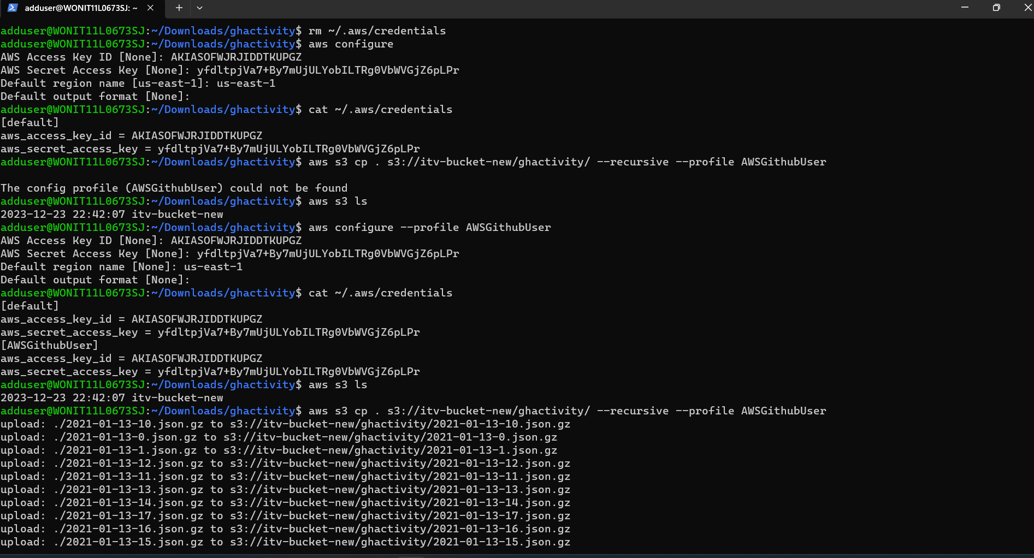

* **aws** s3 **cp** . s3://itv-bucket-new/ghactivity/ --**recursive** --profile **AWSGithubUser = to copy the files from local to s3 folder**
* **aws** s3 **ls** s3://itv-bucket-new/landing/ghactivity/ --profile AWSGithubUser **=to get list of files from the bucket.**

**[Instructions and Code] Upload data to s3**

Let us upload GitHub activity data into s3. You can use s3 web console to create a bucket and then copy the data into the bucket. Based up on the bandwidth, this action will take a considerable amount of time.

* Make sure to have a bucket by name **itv-github**
* Make sure to create folder by name **landing/ghactivity/**
* Upload files into the folder using AWS s3 Web Console

You can also use the below commands to upload the files using CLI. You need to have AWS CLI installed and configured against your AWS account with credentials which have write permissions to s3 bucket. I am using credentials which have write permissions on s3 bucket **itv-github**.

* cd ~/Downloads/ghactivity

**# Single thread**

* aws s3 cp . s3://itv-github/landing/ghactivity/ --recursive --profile **AWSGithubUser**

**# 3 threads in parallel using nohup**

* **nohup** aws s3 cp . s3://itv-github/landing/ghactivity/ --exclude "*" --include "2021-01-13*" --recursive & **nohup** aws s3 cp . s3://itv-github/landing/ghactivity/ --exclude "*" --include "2021-01-14*" --recursive & **nohup** aws s3 cp . s3://itv-github/landing/ghactivity/ --exclude "*" --include "2021-01-15*" --recursive &

**[Instructions and Code] Managing Glue Catalog using AWS CLI**

We can manage Glue Catalog using AWS Glue CLI. Let us understand how to trigger the crawler and also how to validate whether the tables are created or not using AWS Glue CLI commands.

* We need to make sure that the user has required permissions to manage Glue Catalog via CLI.
* We can assign Glue Service Role to the user whose credentials are configured as part of AWS CLI Profile.
* Here are the commands to get the details about a crawler.

1. aws glue list-crawlers --profile itvgithub
2. aws glue get-crawler --name "Retail Crawler" --profile itvgithub
3. aws glue start-crawler --name "Retail Crawler" --profile itvgithub

* Here are the commands to list the tables.

1. aws glue get-databases --profile itvgithub
2. aws glue get-tables --database-name retail_db --profile itvgithub
3. aws glue get-table --database-name retail_db --name orders --profile itvgithub

* Alternatively, we can also use **AWS CLI** to **delete** the files. Make sure to use the appropriate profile.

1. aws s3 ls s3://itv-github/raw/ --profile itvgithub
2. aws s3 ls s3://itv-github/raw/ghactivity/ --profile itvgithub
3. aws s3 **rm** s3://itv-github/raw/ --recursive --profile itvgithub

**[Instructions and Code] Overview of AWS Glue CLI**

Let us get an overview of AWS CLI related to Glue.

* As part of Glue we have several components such as crawler, catalog, jobs, triggers etc.
* We should be able to manage all the Glue components using the below main command.

aws glue

* We can see the list of supported commands for each sub component using help.

aws glue help

* You can explore help on specific commands by using help on top of the sub component’s action.

aws glue list-jobs help

* For each command you can pass the specific set of credentials using profile.

1. **aws glue** list-jobs --profile itvgithub --region us-east-1 = to get a list of glue jobs
2. **aws glue** get-job --profile name --region name =to get a job details
3. **aws glue** get-job-runs --profile name --region name =to get all job details
4. **aws glue** get-job-run --job name name --run-id id --profile name --region name = to get specific job details
5. **aws glue** get-job-bookmark --job name name --profile name --region name = to get a book mark

**Aws Glue Job Bookmark** = it will store all the details of the previous run and if the job is failed in middle then it will start by middle in the next run without starting the entire process by first. The main purpose of glue job bookmark is nothing but to process the data in incremental fashion. As the data is added to the source whenever we run the job. It should only process the files that are added since the last run

* Get job bookmark details. This information will be used to read the data in incremental fashion in subsequent runs. Make sure to keep track of it to compare with subsequent runs.

1. aws glue \
2. get-job-bookmark \
3. --job-name github_json_to_parquet \
4. --profile itvgithub \
5. --region us-east-1

* We can use reset-job-bookmark to reset remove the bookmark. It comes handy to start the jobs from the beginning. We can also reset to a particular run using run id.

1. aws glue reset-job-bookmark \
2. --job-name github_json_to_parquet \
3. --profile itvgithub \
4. --region us-east-1

**[Instructions and Code] Add new data to landing**

Let us upload the data to s3 for the next day. In our case it is **2021-01-16**.

* Downloading the data to the local file system using **wget**.

1. mkdir -p ~/Downloads/ghactivity
2. cd ~/Downloads/ghactivity
3. wget https://data.gharchive.org/2021-01-16-{0..23}.json.gz

* You can upload using Web Console or AWS CLI or boto3. Here are the AWS CLI commands for reference. I will be using CLI on my Mac not on the Docker environment.

1. aws s3 cp . s3://itv-github/landing/ghactivity/ \
2. --exclude "*" \
3. --include "2021-01-16*" \
4. --recursive \
5. --profile itvgithub

**[Instructions and Code] Rerun Glue Job using Bookmark**

Let us rerun the Glue job using the Glue Job Bookmark. Here are the steps followed so far.

* We made sure data is cleaned up in the raw zone.
* We have enabled bookmark before running the job to copy the data for 2021-01-13, 2021-01-14 and 2021-01-15. Here are the commands to validate the folders as well as files.

1. aws s3 ls s3://itv-github/raw/ghactivity/year=2021/month=01/ \
2. --profile itvgithub
4. aws s3 ls s3://itv-github/raw/ghactivity/year=2021/month=01/ \
5. --recursive \
6. --profile itvgithub

* We have validated that bookmark is enabled and also captured for the prior run.

1. aws glue \
2. get-job-bookmark \
3. --job-name github_json_to_parquet \
4. --profile itvgithub \
5. --region us-east-1

* Now let us run the job again either by using the web console or AWS Glue CLI.

1. aws glue \
2. start-job-run \
3. --job-name github_json_to_parquet \
4. --worker-type G.1X \
5. --number-of-workers 10 \
6. --profile itvgithub \
7. --region us-east-1

* We can check the status either by using Web Console or AWS CLI.

1. aws glue \
2. get-job-run \
3. --job-name github_json_to_parquet \
4. --run-id jr_5401519e4b1c68c6b0947a77414ee4bca636fa8f7e128dd836e9d4c665877393 \
5. --profile itvgithub \
6. --region us-east-1

**[Instructions and Code] Validate Job Bookmark and Files for Incremental run**

Let us validate to ensure that the incremental run is as expected. We will review details such as Glue Job bookmark, files in AWS as well as size.

* Run below command and compare with previous output. You will not get direct information related to bookmarks, instead you will only get the metadata. Glue maintains it internally and uses this information to fetch details about last run.

1. aws glue \
2. get-job-bookmark \
3. --job-name github_json_to_parquet \
4. --profile itvgithub \
5. --region us-east-1

* Run below commands to see the new folder related to 2021-01-16.

1. aws s3 ls s3://itv-github/raw/ghactivity/year=2021/month=01/ \
2. --profile itvgithub
4. aws s3 ls s3://itv-github/raw/ghactivity/year=2021/month=01/ \
5. --recursive \
6. --profile itvgithub

* We will also check the size of the overall folder **s3://itv-github/raw/ghactivity/** using AWS Web Console.

**[Instructions and Code] Recrawl the Clue Catalog Table using CLI**

Let us recrawl the Glue Catalog table using Web Console or AWS CLI.

* We should also run queries to ensure that data is copied as expected.
* However, the new partitions added might not be visible for querying using tools like Athena.
* We need to crawl the table to refresh partitions. Before crawling, you can go to the Glue Catalog Table using AWS Web Console and check existing partitions.
* You can also run below AWS CLI command to check the table properties.

1. aws glue get-table \
2. --database-name itvghrawdb \
3. --name ghactivity \
4. --profile itvgithub \
5. --region us-east-1
7. aws glue get-partitions \
8. --database-name itvghrawdb \
9. --table-name ghactivity \
10. --profile itvgithub \
11. --region us-east-1

* You can either crawl using Web Console or Command line.
* Here is the command to crawl so that the table definition is refreshed with the new partition. You can go to the web console and verify whether the new partition is added or not.

1. aws glue start-crawler --name "GHActivity Raw Crawler" \
2. --profile itvgithub \
3. --region us-east-1

**[Instructions and Code] Run Athena Queries for Data Validation**

Run the same athena queries as earlier and compare the results as well as performance. Make sure to choose the new database **itvghrawdb**.

* When we recrawl the table, we might run into a known issue with Athena. You can refer to [this document](https://www.google.com/url?q=https://docs.amazonaws.cn/en_us/athena/latest/ug/updates-and-partitions.html&sa=D&source=editors&ust=1629529826660000&usg=AOvVaw2KKPih8iFjZ9ykQ8RgKtGs) about the details.
* You can run the below scripts to drop the partitions and add them using Athena.

1. ALTER TABLE itvghrawdb.ghactivity
2. DROP PARTITION (year = '2021', month = '01', day = '16');
4. MSCK REPAIR TABLE itvghrawdb.ghactivity;

* Get the number of records from the table.

SELECT count (1) FROM ghactivity;

**AWS EMR:**

* **create a key pair** and download the .pem file from ec2
* **mv** ~/source_location ~/. ssh to move the files from source to target location
* **Chmod 600 ~/.**file location.pem-to the remove the read permission from the file for other users except owner.
* **ls –ltr ~/ .**file_location.pem
* **set up the EMR Cluster**
  1. **software configurations** = hadoop and spark
  2. Choose **glue data catalog** for spark table metatable – to manage the **metastore** tables of **spark**.
  3. uniform instances group
  4. **networking** = default VPC
  5. **cluster nodes and instances** = 1 master ,2 cores and 0 task
  6. **cluster scaling** = enable cluster scaling and EMR managed scaling
  7. **core and task units** = 2 min , 8 max, 2 on-demand and max core node = 2
  8. **EBS** volume = 10
  9. Give the **cluster** **name**
  10. Enable the **logging** to check any logs when emr cluster is terminated or stopped
  11. **Debugging** enable
  12. **Termination** **protection** enable = to control from anyone not to terminate our cluster
  13. Add the **EC2** **key** pair
  14. Create the emr cluster
* **Steps**: where we can add any spark jobs in the step section
* **Monitoring** : where you can monitor the EMR cluster
* **Hardware** :get all master and core nodes and scaling policy related information
* **Configurations** : all the properties are over-ridden here
* **Events:** containsall the information related to the cluster setting upfrom **begin** to **end**
* **Bootstrap:** is the downloading all the prerequisites which are needed while running the spark application on cluster
* **Connecting to emr master node using SSH in terminal:** 
  1. Copy master public dns url
  2. Test by a command - **telnet** url 24(port number)
  3. **Ctrl + ] = to come out**
  4. **quit**
  5. **ls –ltr ~/.**file_location.pem
  6. To pass this key explicitly

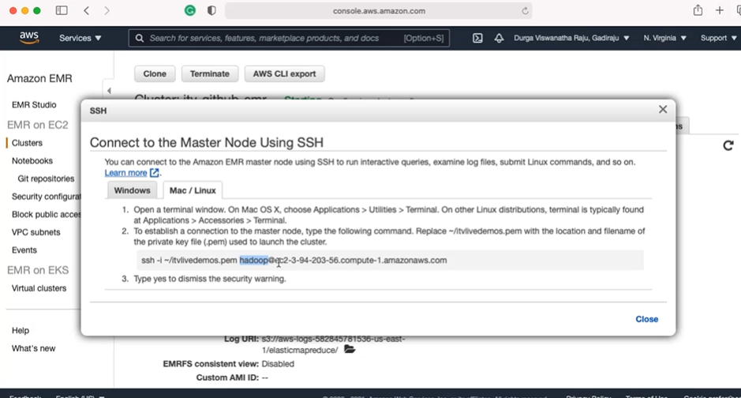

* 1. **Uname –a =** to get the linux version
  2. **Sudo su – root =** switch to root user of the master node using super command

**Amazon Managed Workflow for Apache Airflow:-**

* Is a managed environment in aws cloud environment
* Open source
* Workflow management tool
* For ETL , ML pipelines and Devops
* Fully managed by Aws
* Automating Scaling